CSS GENDER STUDIES
T7QA
The Question Answers
Topic 7 · Gender-Based Violence and the Three Case Studies — every past question answered as a model
WHAT THIS DOCUMENT GIVES YOU
◆ All nine CSS questions on Topic 7 (2016–2025) and the three short notes, answered in full
◆ An answer map for every answer — each branch a numbered heading
◆ The command words and limbs of every question decoded
◆ Model answers of 1,000–1,300 words (notes 550–650) with current data — PDHS, SSDO, HRCP — and the Punjab Act 2016 inside every heading
◆ Why each answer scores — what the examiner rewards
Federal Public Service Commission · CSS Competitive Examination · Optional paper, 100 marks
Written for CE-2027 onwards · Record: CE-2016 to CE-2026 · Facts current to September 2026

Contents
HOW TO BUILD THE CONTENTS
The contents list below fills itself in. When Word asks "This document contains fields that may refer to other files. Update the fields?", click Yes.
If it does not ask: right-click the grey contents area → Update Field → Update entire table → OK. On a Mac, Control-click the same area. Or press Ctrl + A, then F9 (Windows), to update every field at once. Repeat after any edit, before you export to PDF.

Right-click here and choose Update Field to build the contents.

How to Use These Answers

What is in this document
Table 1 · The questions answered for Topic 7, in the order they were set.
No. | Question | Year · Q | Family
1 | What are the sites and forms of violence against women in Pakistan and how in your view this menace can be eliminated from our society? | CSS 2016 · Q3 | GBV — forms, sites and strategies to eliminate it
2 | What are the different forms of gender-based violence and, in your opinion, what could be the workable strategies to eliminate gender-based … | CSS 2017 · Q3 | GBV — forms, sites and strategies to eliminate it
3 | Honour killing | CSS 2017 · Q8(a) | Honour killing
4 | Government initiatives for combating violence against women | CSS 2018 · Q8(c) | GBV — laws and state initiatives
5 | Explain the structural and direct forms of violence against women in Pakistani society by highlighting the case study of Mukhtaran Mai. | CSS 2019 · Q7 | GBV — forms, sites and strategies to eliminate it; Case study — Mukhtaran Mai
6 | Comment on the power-and-control relationship in gender-based violence. | CSS 2020 · Q7 | GBV — causes, theories, power and control
7 | Discuss the background of the two Oscar-winning documentaries by Sharmeen Obaid-Chinoy. | CSS 2020 · Q8 | Case study — Sharmeen Obaid-Chinoy
8 | Define gender-based violence. Explain various forms of violence against women in Pakistan and devise practical strategies helpful in eradica… | CSS 2023 · Q8 | GBV — forms, sites and strategies to eliminate it
9 | What is gender-based violence? What forms of gender-based violence are given in the Punjab Protection of Women Against Violence Act 2016? Wh… | CSS 2024 · Q6 | GBV — laws and state initiatives; GBV — forms, sites and strategies to eliminate it
10 | What are the root causes that lead to gender-based violence? How do these factors intersect and perpetuate violence against women in Pakista… | CSS 2025 · Q2 | GBV — causes, theories, power and control
11 | Critically examine and evaluate Malala Yousafzai's achievements and activism for promoting girls' education in local and global contexts. | CSS 2025 · Q8 | Case study — Malala Yousafzai
12 | The role of masculinity studies in understanding violence against women in Pakistani society | CSS 2026 · Q8(b) | Masculinities and violence against women

How every answer is built
1. The question, exactly as set, with its year and number.
2. The answer map — a mind map whose centre states what the question asks, part by part. Every branch is one numbered heading of the answer, and every point on it is a short phrase that makes complete sense on its own — so the map alone tells the examiner the whole argument. Draw a quick version in the margin of your answer book before you write.
3. Decoding the question — the command words and what each part demands.
4. The model answer — 1,000 to 1,300 words (550 to 650 for a short note), the length a strong candidate can write in about thirty minutes. It is built in two levels: main headings 1, 2, 3… taken from the question's own words, and sub-headings i), ii), iii)… under them. The introduction always has a simple definition and the argument. Each sub-heading answers one point in a short paragraph with the key words in bold. Every answer has at least one figure besides the answer map (a grid, cycle, pyramid, tree, timeline or comparison), a Pakistan angle and a balanced conclusion.
5. Why this answer scores — what the examiner rewards in it.
EXAMINER'S EYE · TOPIC 7 REWARDS A FIVE-PART FRAME
Every violence question in this topic asks for two or three things at once — define, explain forms, devise strategies, identify causes, describe consequences. Notice how each answer below uses the same five-part frame: (1) a precise definition (DEVAW 1993; the Punjab Act 2016); (2) current data — PDHS 2017–18 (28%), SSDO 2024 (32,617 cases; conviction about 0.5%), HRCP 2024 (405 honour killings); (3) theory — power and control, Galtung, the ecological model; (4) the forms, causes, laws or consequences the question names; and (5) strategies organised as prevention, protection, prosecution, provision and partnership. The three near repeats — 2016, 2017 and 2023 — are answered separately to show how to re-cut the same knowledge for "sites", "workable" and "practical". The case studies are always analysed, not just narrated.

Answer 1 · The Sites and Forms of Violence against Women in Pakistan, and How to Eliminate It (CSS 2016)
AT A GLANCE · CSS 2016 · Q3 · 20 MARKS
What are the sites and forms of violence against women in Pakistan and how in your view this menace can be eliminated from our society?

The answer map
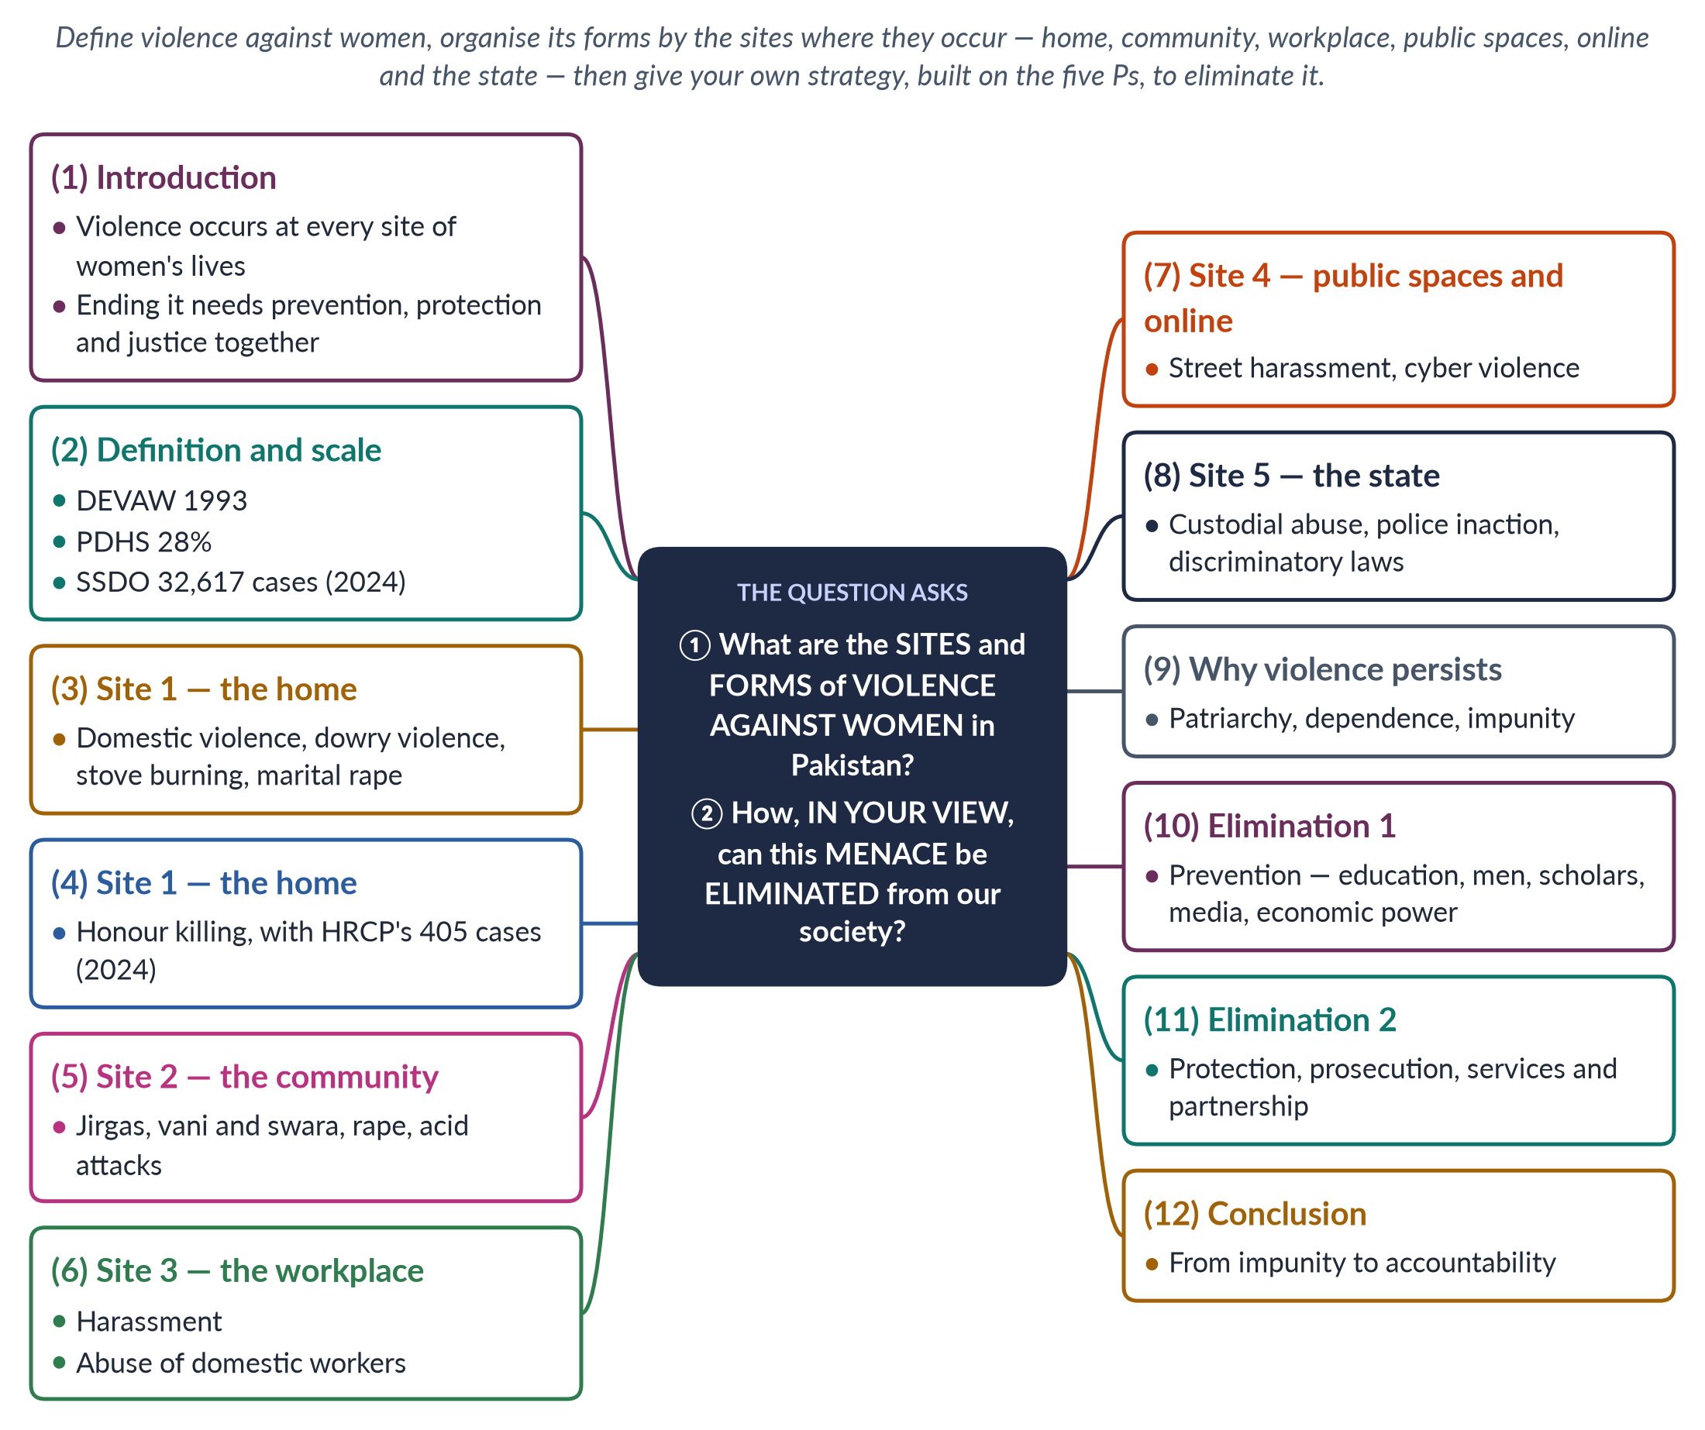
Figure 1 · The answer map: every branch is one numbered heading of the model answer below.

Decoding the question
Two parts. "Sites and forms" asks where violence happens (home, community, workplace, public spaces, online, the state) and what kinds occur at each site — so organise by site, not as a random list. "How in your view this menace can be eliminated" asks for your own strategy, which must answer the causes you identify. Give data, laws and cases throughout.

The model answer

1. Introduction

i) Definition
The UN Declaration on the Elimination of Violence against Women (1993) defines violence against women as any act of gender-based violence that results in physical, sexual or psychological harm, including threats, coercion or deprivation of liberty, in public or private life.

ii) The argument
In Pakistan, violence follows women into every site of their lives — the home, the community, the workplace, public spaces, the internet and even the institutions of the state. It persists because of patriarchal norms, women's economic dependence and impunity. Eliminating it therefore requires a combined strategy: prevention to change norms, protection to keep women safe, and prosecution to end impunity.

2. Definition and scale
The Pakistan Demographic and Health Survey 2017–18 found that 28% of ever-married women had experienced physical violence since age 15, and 34% spousal physical, sexual or emotional violence; 56% of those who suffered violence never sought help. In 2024 the Sustainable Social Development Organization (SSDO) recorded 32,617 reported cases of gender-based violence. These reported cases are only the visible tip of a much larger problem. Worldwide, the WHO estimates that about 1 in 3 women experience physical or sexual violence in their lifetime, so Pakistan's problem is part of a global pattern — but one made worse by weak enforcement.

3. Site 1 — the home: domestic violence

i) Domestic violence
The home is the most dangerous site. Women are beaten, burned, starved, confined and threatened by husbands and in-laws; marital rape is common but rarely recognised. Economic abuse — taking a woman's income or denying her food and money — is widespread.

ii) Dowry violence and stove burning
Brides whose families cannot meet dowry demands face harassment and beating. Some are burned in "kitchen accidents" — stove burning — that are often disguised murders.

4. Site 1 — the home: honour killing
Women who choose their own husbands, seek divorce or are merely suspected of a relationship may be killed by fathers, brothers or husbands claiming to defend family honour — karo-kari in Sindh, siyahkari in Balochistan. The Human Rights Commission of Pakistan recorded at least 405 honour killings in 2024. The murder of Qandeel Baloch by her brother in 2016 showed how family members kill and then claim forgiveness from their own relatives.

5. Site 2 — the community

i) Parallel justice
Jirgas and panchayats of male elders order vani and swara — giving girls in marriage to settle disputes — and even punishment rape, as in the case of Mukhtaran Mai (2002).

ii) Rape and abduction
In 2024, 5,339 rapes and 24,439 kidnappings and abductions were reported. The rape and murder of six-year-old Zainab Ansari in Kasur (2018) shocked the nation.

iii) Acid attacks
Acid is thrown on women who refuse marriage proposals or advances, leaving them blind and disfigured. The Acid Control and Acid Crime Prevention Act 2011 provides 14 years to life imprisonment, but attacks continue.
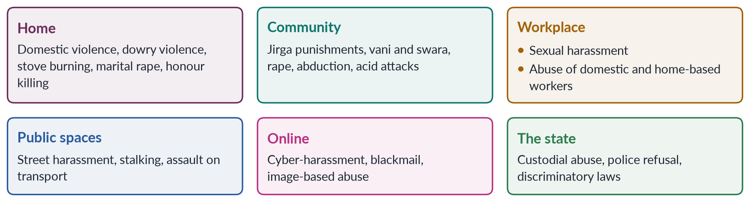
Figure 2 · The sites of violence against women in Pakistan and the main forms at each.

6. Site 3 — the workplace
Women in offices, factories, fields and hospitals face sexual harassment — unwelcome advances, demands for favours and hostile environments. Domestic workers, many of them young girls, are among the most vulnerable, and cases of severe abuse in employers' homes have repeatedly come to light. The Protection against Harassment of Women at the Workplace Act 2010, amended in 2022, requires inquiry committees and created ombudspersons, but many workplaces, especially informal ones, do not comply.

7. Site 4 — public spaces and online

i) Public spaces
Street harassment, staring, stalking and groping on buses and in markets restrict women's mobility and keep many from jobs and colleges. Section 509 of the Penal Code (amended 2010) punishes harassment in public places.

ii) Online
With smartphones has come cyber violence — harassment, fake profiles, blackmail with private images and threats. The Prevention of Electronic Crimes Act 2016 criminalises such acts, but reporting is low.

8. Site 5 — the state
The state itself can be a site of violence: custodial abuse in police stations, police refusal to register complaints, and laws that once discriminated — under the Zina Ordinance (1979), rape victims who could not prove their case risked prosecution for adultery until the Protection of Women Act 2006.

9. Why the menace persists

i) Patriarchy
Norms of male authority and family honour treat women's bodies and choices as men's business.

ii) Economic dependence
With female labour-force participation at only 24.4%, many women cannot leave abusive homes.

iii) Impunity
SSDO found conviction rates of about 0.5% for rape and honour killing in 2024. Police refuse FIRs, families force settlements, and trials take years.

10. Elimination 1: prevention

i) Education and men
Teach gender equality and respect in schools, keep girls in school, and engage men and boys — as the NGO Rozan does — to challenge the idea that violence proves manhood.

ii) Scholars and media
Mobilise religious scholars to declare honour killing, forced marriage and denial of inheritance contrary to Islam; use dramas and campaigns to show respectful relationships.

iii) Economic power
Women's jobs, inheritance and cash transfers through the Benazir Income Support Programme increase their bargaining power and their ability to leave abuse.

11. Elimination 2: protection, prosecution, services and partnership

i) Protection
Extend helplines (Punjab's 1043), shelters and one-stop centres like the Violence against Women Centre in Multan (2017) to every district; enforce protection orders under the Punjab Protection of Women against Violence Act 2016.

ii) Prosecution
Make FIR registration compulsory, train police and prosecutors, recruit women officers, build DNA and forensic capacity, use special courts under the Anti-Rape (Investigation and Trial) Act 2021, and make honour crimes fully non-compoundable.

iii) Services and partnership
Provide free legal aid, medical care and counselling; build a national GBV database; and co-ordinate police, health, courts and NGOs.
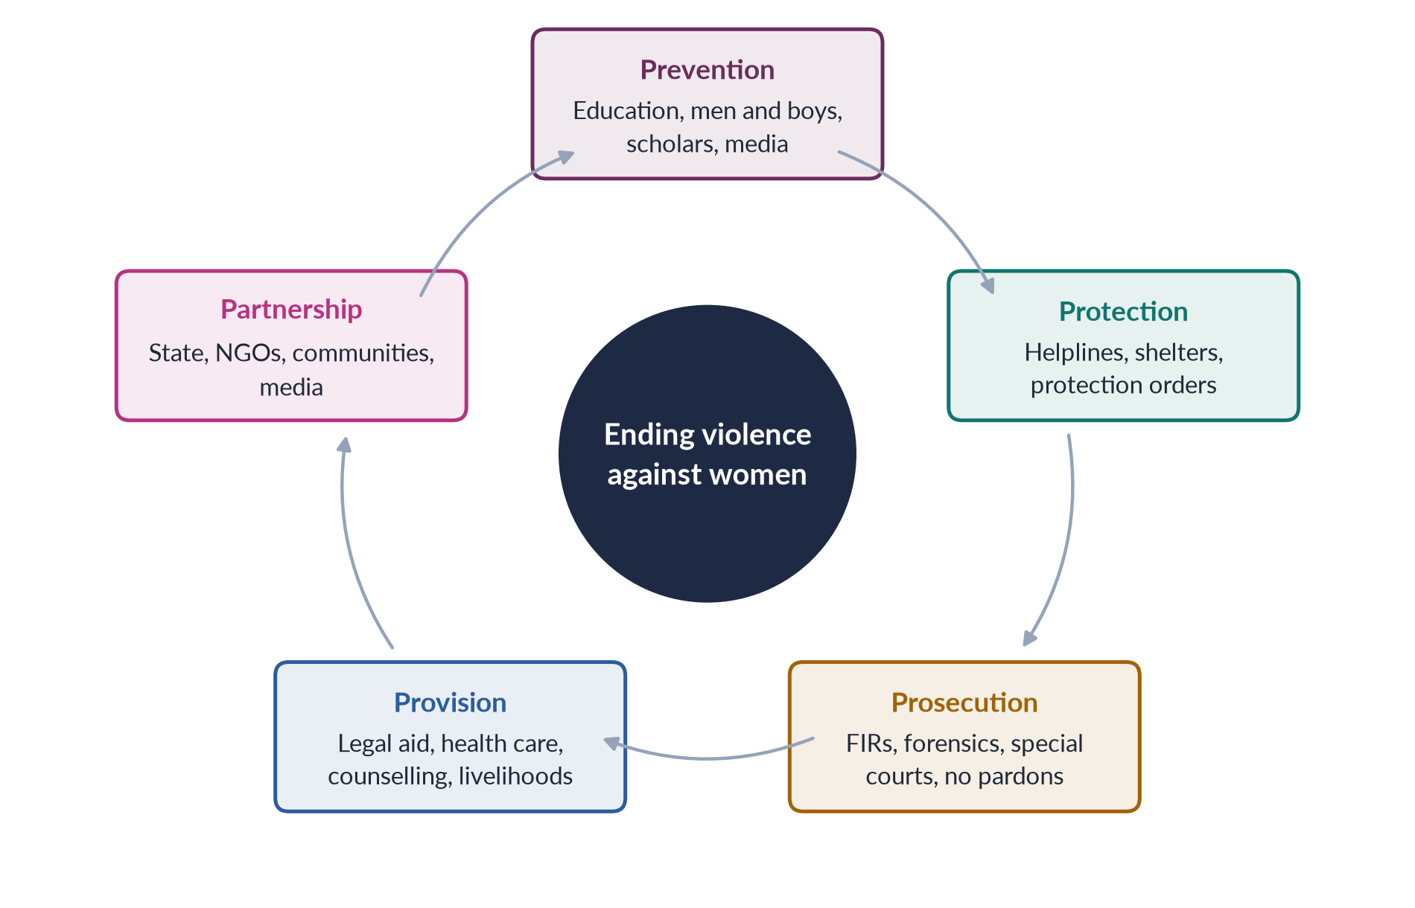
Figure 3 · A strategy to eliminate violence against women — the five Ps.

12. Conclusion
Violence against women in Pakistan is not confined to one place — it reaches women at home, in the community, at work, in the street, online and in custody. Its many forms share common roots in patriarchy, dependence and impunity. In my view, the menace can be eliminated only by attacking all three at once: changing norms through education and men's engagement, giving women economic independence, and making justice certain through effective policing and courts. When perpetrators expect punishment rather than pardon, violence will begin to fall.

Why this answer scores
- Organises forms by site, exactly as the question asks.
- Supports every site with data, laws or cases (PDHS, SSDO, HRCP, Zainab, Mukhtaran Mai).
- Links causes to a personal strategy built on the five Ps.
- A grid and a cycle figure summarise the analysis and the strategy.

Answer 2 · Forms of Gender-Based Violence and Workable Strategies to Eliminate It (CSS 2017)
AT A GLANCE · CSS 2017 · Q3 · 20 MARKS
What are the different forms of gender-based violence and, in your opinion, what could be the workable strategies to eliminate gender-based violence from Pakistani society?

The answer map
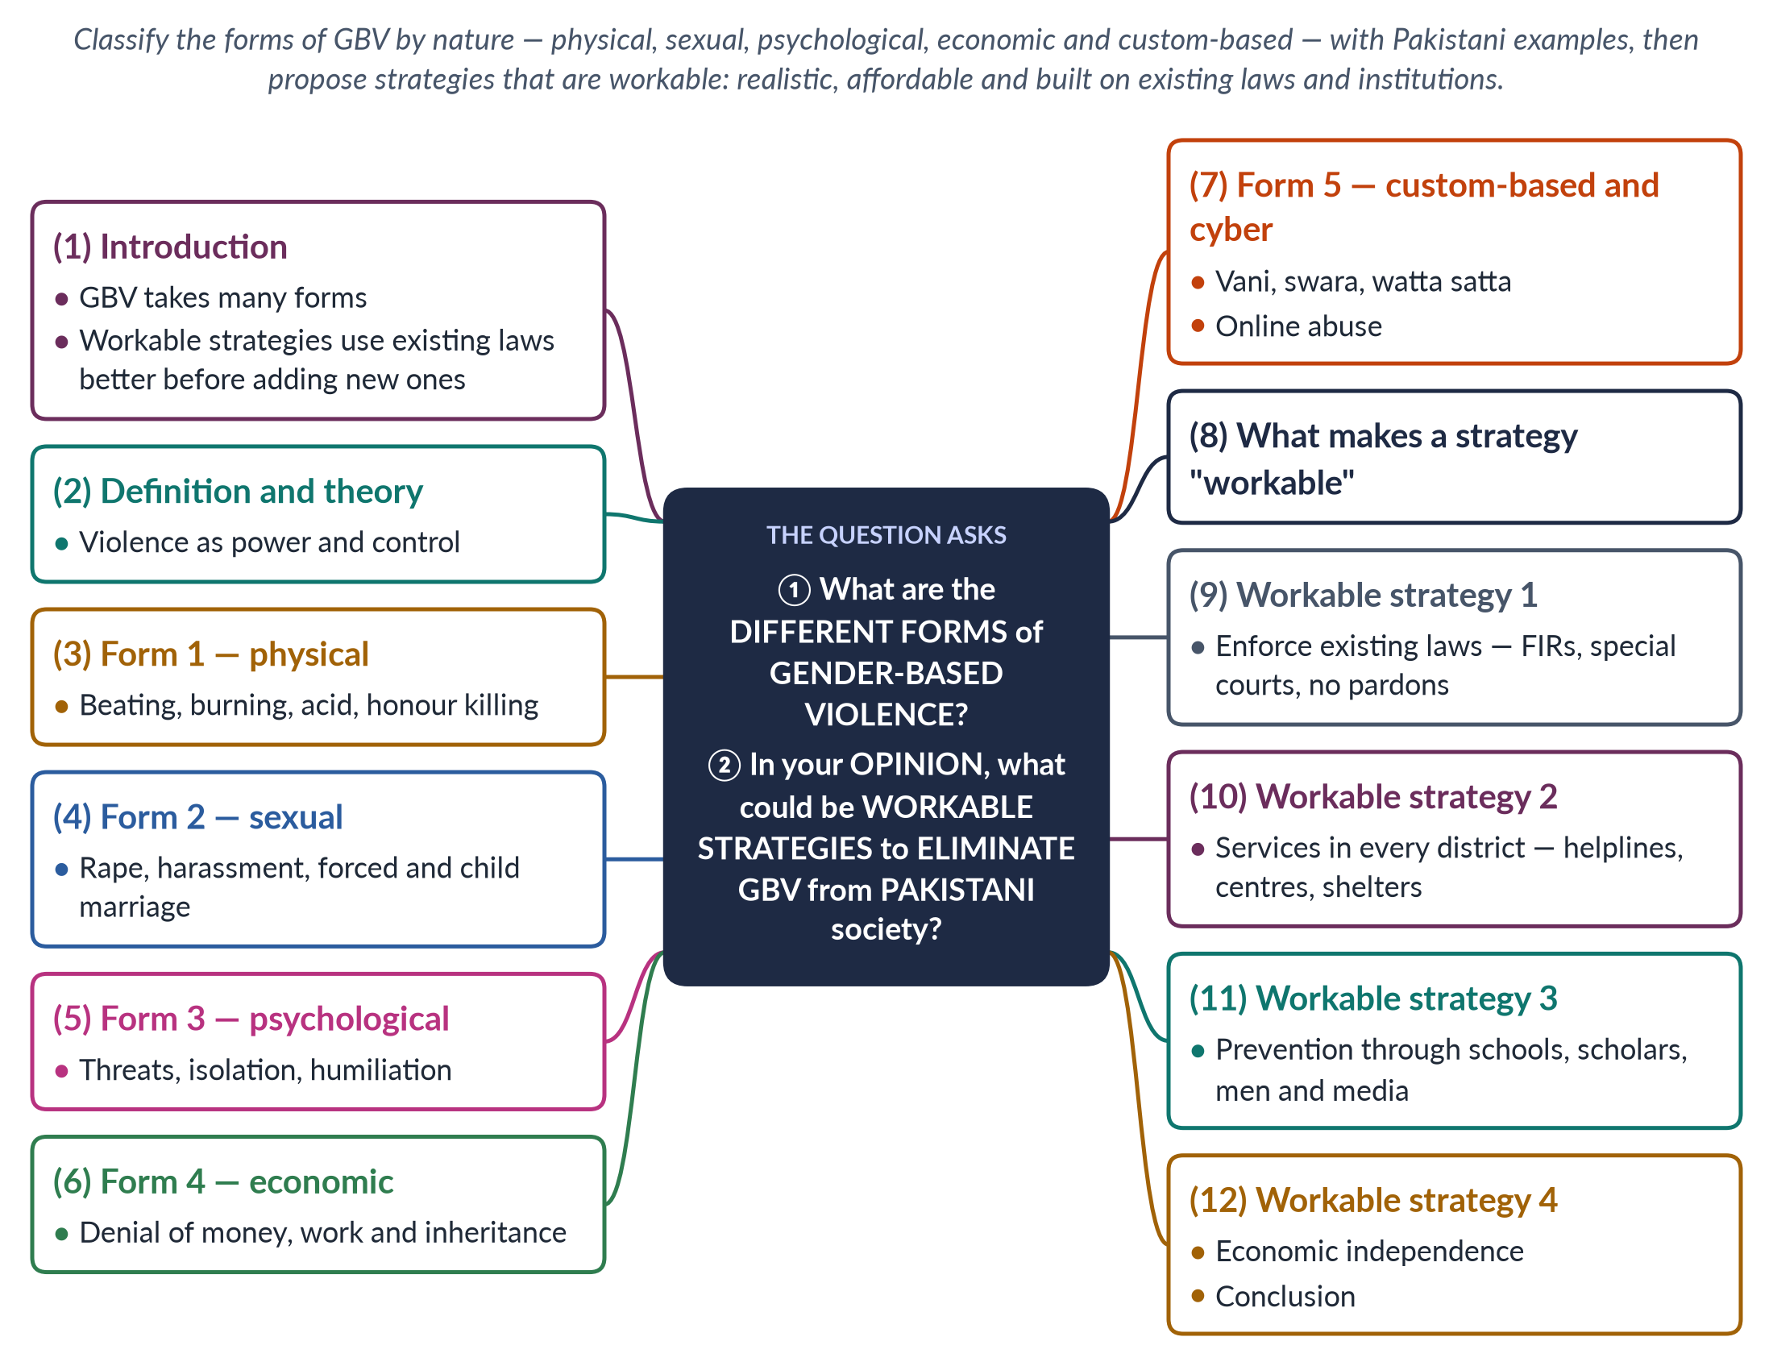
Figure 4 · The answer map: every branch is one numbered heading of the model answer below.

Decoding the question
Two parts. "Different forms of gender-based violence" asks for a classification — the clearest is by nature: physical, sexual, psychological and economic, plus custom-based and cyber violence. "Workable strategies" is the key phrase: the examiner wants strategies that are realistic and practical in Pakistan, not a wish-list. Explain what makes a strategy workable and give your opinion.

The model answer

1. Introduction

i) Definition
Gender-based violence is harm directed at a person because of their gender, rooted in unequal power between women and men; it includes physical, sexual, psychological and economic harm and threats of such harm.

ii) The argument
GBV in Pakistan takes many forms, from beating and acid attacks to economic control and custom-based practices such as vani. In my opinion, the most workable strategies are not new laws but the effective use of existing laws and institutions — enforcement, services in every district, and prevention through institutions that already reach people, such as schools, mosques and the media — combined with women's economic independence.

2. Definition and theory
Feminist theory and the Duluth Power and Control Wheel (1981) show that GBV is mainly a means of power and control — men using force, threats and control of money to dominate women. Social learning theory adds that violence is learned in families and communities and continues when it goes unpunished. These theories explain why GBV takes so many forms: each is a different tool of control. The ecological model of Lori Heise (1998) adds that causes operate at the individual, family, community and society levels — so strategies must work at all four.

3. Form 1 — physical violence
Physical violence includes slapping, beating, kicking, burning and murder. The PDHS 2017–18 found that 28% of ever-married women had experienced physical violence since age 15. Its extreme forms are acid attacks, which blind and disfigure women, and honour killings: the Human Rights Commission of Pakistan recorded at least 405 in 2024. Stove burning, disguised as kitchen accidents, is another lethal form.

4. Form 2 — sexual violence

i) Rape and sexual assault
5,339 rapes were reported in 2024 (SSDO), with a conviction rate of about 0.5%; marital rape and child sexual abuse are heavily under-reported.

ii) Harassment
Sexual harassment at work, in educational institutions, on public transport and online limits women's freedom.

iii) Forced and child marriage
Marriage without consent, or before a girl is ready, exposes her to repeated sexual violence and ends her schooling. Only Sindh (2013) and Islamabad (2025) have set the minimum age at 18.

5. Form 3 — psychological violence
Threats of divorce or of a second marriage, taunts about dowry or about failing to bear sons, insults, humiliation, isolation from parents and friends, confiscation of phones, and constant surveillance are forms of psychological or emotional abuse. They leave no visible marks but cause depression, anxiety and sometimes suicide. The Punjab Protection of Women against Violence Act 2016 recognises psychological abuse as violence.

6. Form 4 — economic violence
Economic abuse includes taking a woman's salary or dowry, forbidding her to work, denying her food or money for medical care, and depriving her of her share of inheritance. Economic dependence then traps her in an abusive home. The Punjab Act defines economic abuse, and the Enforcement of Women's Property Rights Act 2020 offers a remedy for denied inheritance.

7. Form 5 — custom-based and cyber violence

i) Custom-based violence
Vani and swara (girls given in settlement of disputes), marriage to the Qur'an, forced marriage and watta satta (exchange marriage) are rooted in custom. The Prevention of Anti-Women Practices Act 2011 made most of them crimes.

ii) Cyber violence
Blackmail with private images, fake profiles and online harassment have grown with smartphones; the Prevention of Electronic Crimes Act 2016 applies.
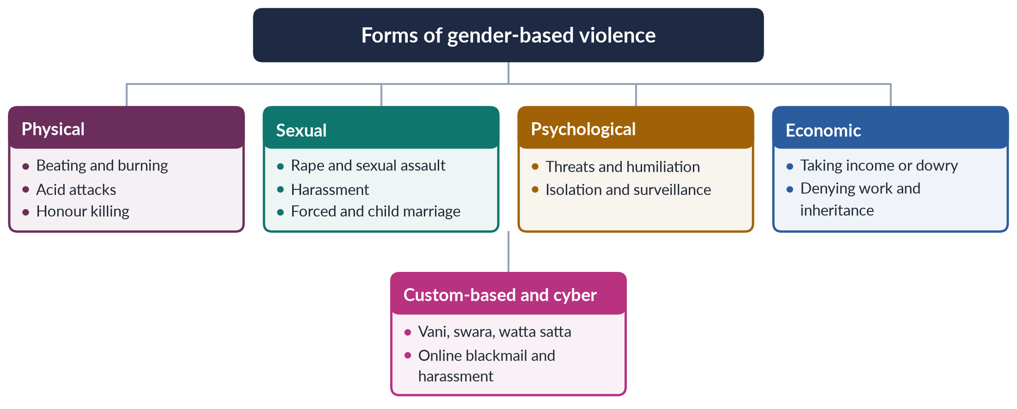
Figure 5 · The forms of gender-based violence in Pakistan.

8. What makes a strategy "workable"
A strategy is workable if it is (1) realistic within Pakistan's resources and institutions; (2) built on existing laws rather than waiting for new ones; (3) measurable, so that progress can be checked; and (4) acceptable to society, so that it is not rejected as foreign. Pakistan already has strong laws — on harassment (2010), acid (2011), anti-women practices (2011), honour killing and rape (2016), and anti-rape investigation (2021). The gap is implementation: SSDO found conviction rates of about 0.5% for rape and honour killing in 2024. A workable strategy therefore starts where the system is failing.

9. Workable strategy 1: enforce existing laws

i) Compulsory FIRs
Make registration of complaints compulsory and discipline officers who refuse; recruit more women police so that survivors can report to a woman.

ii) Special courts and investigation
Use the Special Sexual Offences Investigation Units and special courts of the Anti-Rape (Investigation and Trial) Act 2021 in every district; build DNA and forensic capacity; protect witnesses.

iii) No pardons
Make honour killings and other GBV crimes fully non-compoundable, so that families cannot "forgive" killers.

10. Workable strategy 2: services in every district
Extend the model of the Violence against Women Centre, Multan (2017) — a one-stop centre for FIRs, medical examination, legal aid and counselling — to every district. Keep helplines such as 1043 answering around the clock, and make shelters safe and dignified rather than places of confinement. These services are affordable because they combine existing police, health and social-welfare staff under one roof. They also reduce the humiliation of moving from police station to hospital to court, which today makes many women give up.

11. Workable strategy 3: prevention through existing institutions

i) Schools
Add lessons on gender equality, consent and non-violent conflict resolution; keep girls in school to delay marriage.

ii) Mosques
Engage imams to preach in Friday sermons that honour killing is murder and that Islam forbids forced marriage and denial of inheritance.

iii) Men and media
Work with boys and men, as Rozan does, and use television dramas and the 16 Days of Activism to change attitudes.

12. Workable strategy 4: economic independence; conclusion

i) Economic independence
Women's jobs, inheritance, microfinance and cash transfers through BISP give women the means to resist and leave abuse; enforcing the 2020 property law costs little but changes power within families. A woman who owns land or earns her own income is far less likely to be trapped by violence.

ii) Conclusion
GBV in Pakistan is physical, sexual, psychological, economic and custom-based, and each form is a tool of control. In my opinion, the most workable strategy is to make existing laws real — through compulsory FIRs, special courts, one-stop centres in every district and an end to pardons — while using schools, mosques and the media to change norms and giving women economic independence. Pakistan does not lack laws; it lacks their enforcement.

Why this answer scores
- Classifies the forms clearly by nature, with data and laws for each.
- Defines what makes a strategy "workable" — the key word — before proposing any.
- Builds strategies on existing laws and institutions, showing realism.
- A tree figure organises the forms at a glance.

Answer 3 · Short Note: Honour Killing (CSS 2017)
AT A GLANCE · CSS 2017 · Q8(A) · 10 MARKS
Write short notes on the following: Honour killing

The answer map
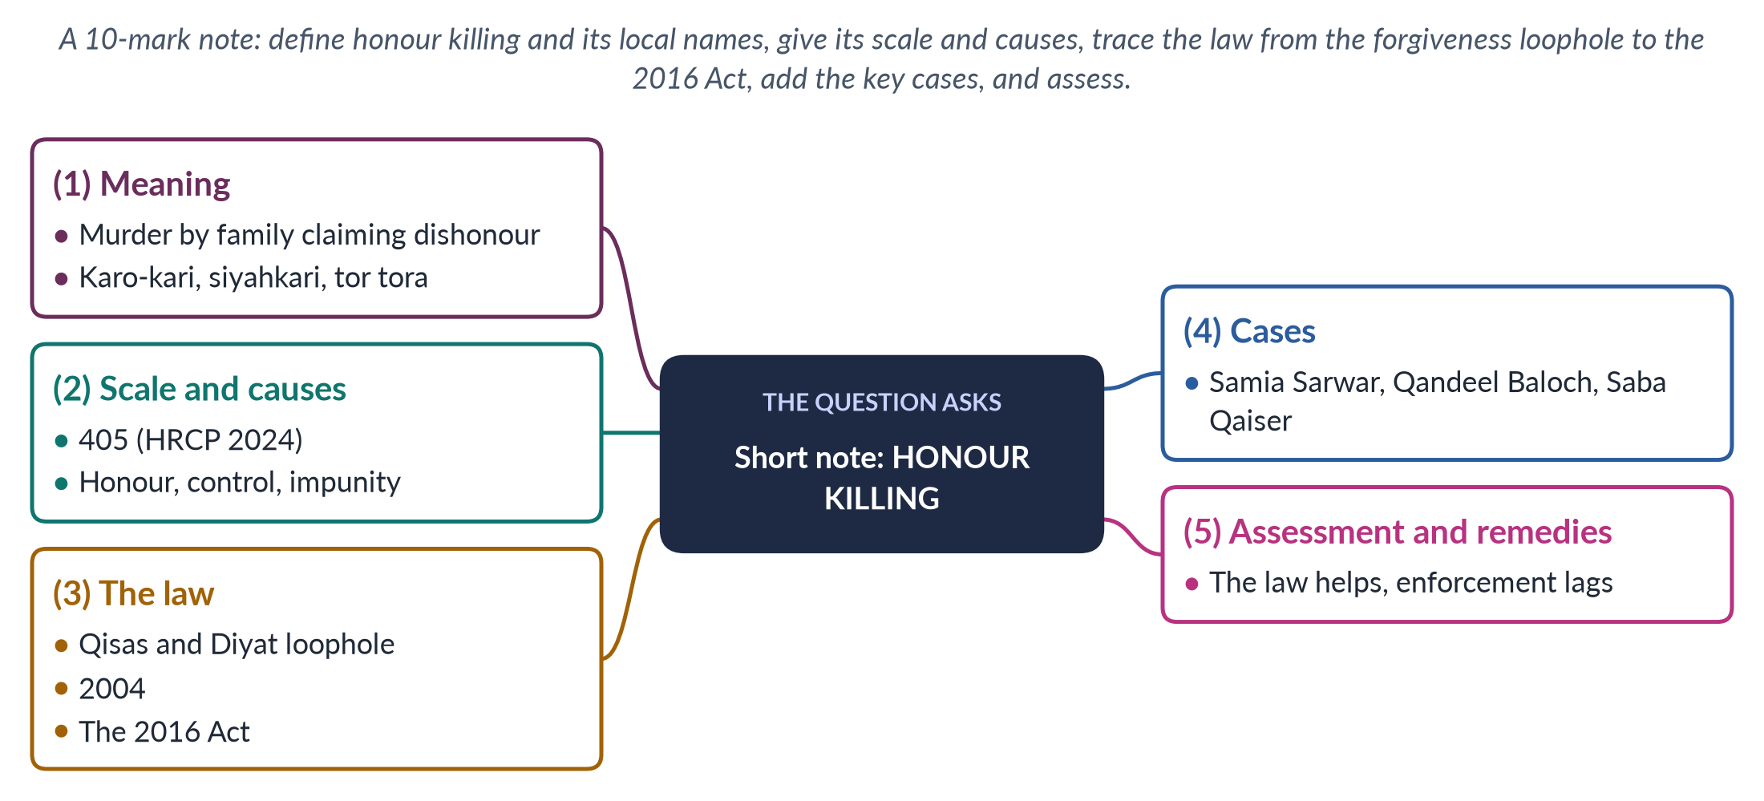
Figure 6 · The answer map for the short note: every branch is one headed point.

Decoding the question
A short note of 10 marks: about 550–650 words. Define honour killing and give its local names, its scale, its causes, the legal history (especially the 2016 Act), two or three cases, and a brief assessment with remedies.

The model answer

1. Meaning
An honour killing is the murder of a person — usually a woman — by her own family or community, who claim that she has brought shame on them. The "offence" may be marrying by choice, seeking divorce, a suspected relationship, refusing an arranged marriage, being raped, or even posting on social media. Men are sometimes killed too, usually the man accused of the relationship. It is known as karo-kari in Sindh, siyahkari in Balochistan, tor tora in Khyber Pakhtunkhwa and kala kali in Punjab.

2. Scale and causes
The Human Rights Commission of Pakistan recorded at least 405 honour killings in 2024, and the Sustainable Social Development Organization counted 547 reported cases with a conviction rate of only about 0.5%. Many more are hidden as suicides or accidents, and bodies are often buried quickly without post-mortems.
The causes are a belief that family honour lives in women's bodies; men's fear of being called be-ghairat (without honour); control over marriage and property — false accusations are sometimes used to grab land; approval by jirgas; and, above all, impunity. Feminist theory sees honour killing as the most extreme form of men's power and control over women's choices; masculinity studies adds that men kill to prove their ghairat before other men.

3. The law
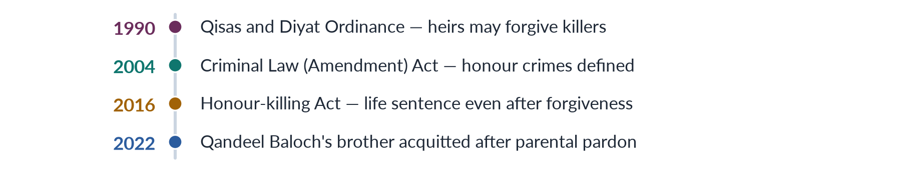
Figure 7 · The law on honour killing.
Under the Qisas and Diyat Ordinance (1990; Act of 1997), murder became compoundable: the victim's heirs could forgive the killer. In honour killings, the heirs were usually the killer's own family, so killers walked free. The Criminal Law (Amendment) Act 2004 defined honour crimes and raised penalties but left this loophole open. The Criminal Law (Amendment) (Offences in the name or pretext of Honour) Act 2016, passed by a joint sitting of Parliament in October 2016, provides that even if the heirs forgive the death penalty, the court must impose life imprisonment. The bill had been moved by Senator Sughra Imam in 2014. A 2026 MCQ asked for this Act as the law that restricted the family-forgiveness loophole.

4. Cases
- Samia Sarwar (1999) was shot dead in the Lahore office of her lawyers, Hina Jilani and Asma Jahangir, with her mother present, for seeking a divorce from an abusive husband; no one was punished, and some legislators defended the killing.
- In 2025, a couple in Degari, Balochistan, were shot dead on a tribal chief's orders for marrying by choice; a viral video forced arrests.
- Qandeel Baloch, a social-media celebrity, was strangled by her brother in Multan in July 2016; her murder pushed the 2016 Act through, but her brother was acquitted by the Lahore High Court in 2022 after her parents pardoned him.
- Saba Qaiser, 19, was shot by her father and uncle and thrown into a river near Gujranwala in 2014; she survived. Under community pressure she "forgave" them. Sharmeen Obaid-Chinoy's film about her, A Girl in the River, won the 2016 Oscar, and Prime Minister Nawaz Sharif declared that there is "no honour in honour killing".

5. Assessment and remedies
The 2016 Act was a necessary reform, but impunity continues because families re-label killings as ordinary murders, witnesses turn hostile, and investigations are weak. Remedies include making all such killings fully non-compoundable, training police and judges to recognise honour motives, investigating every suspicious death of a woman, prosecuting jirgas that order killings, protecting couples who marry by choice, and enlisting religious scholars to declare clearly that honour killing is murder, not justice. Women's economic independence and shelters for those at risk would also give potential victims a way out. There is no honour in killing a woman; the dishonour lies in letting killers go free.

Why this answer scores
- Gives the definition, local names and up-to-date data.
- Traces the legal history precisely, including the 2016 Act (an MCQ favourite).
- Uses three cases to show both progress and the limits of reform.
- A timeline figure makes the legal story clear in seconds.

Answer 4 · Short Note: Government Initiatives for Combating Violence against Women (CSS 2018)
AT A GLANCE · CSS 2018 · Q8(C) · 10 MARKS
Write short notes on any TWO: Government initiatives for combating violence against women

The answer map
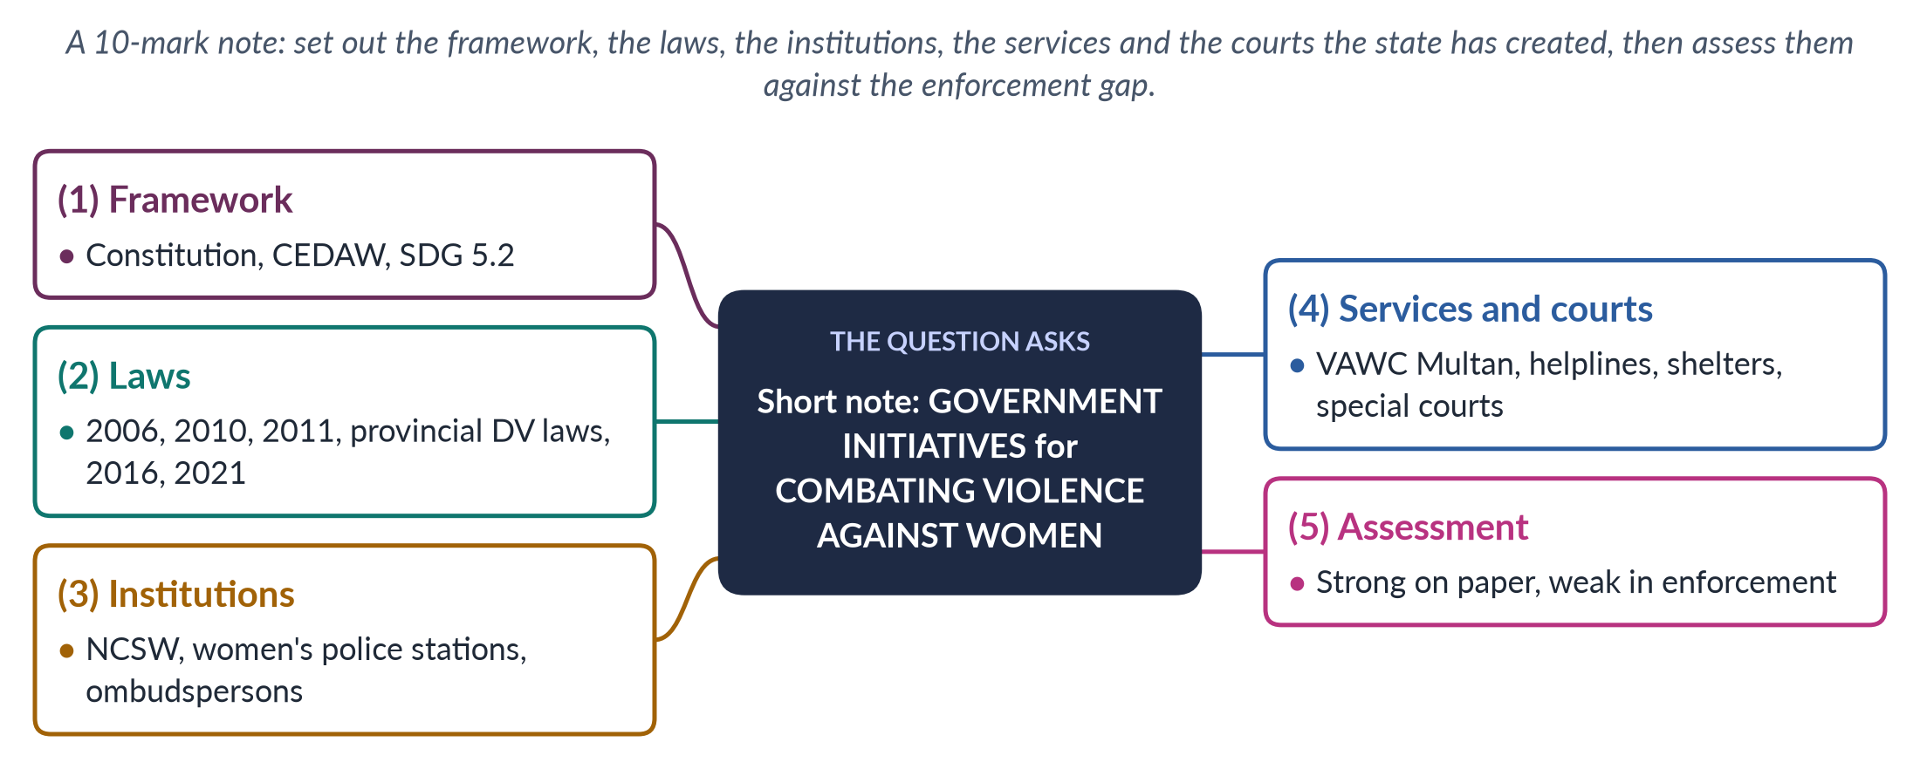
Figure 8 · The answer map for the short note: every branch is one headed point.

Decoding the question
A short note of 10 marks: about 550–650 words. "Government initiatives" means what the state has done — laws, policies, institutions, services and courts — not what NGOs have done. Organise them clearly and end with a short assessment.

The model answer

1. The framework
The Constitution guarantees security of person (Article 9), dignity (Article 14) and equality, with special provision for women (Article 25). Pakistan acceded to CEDAW in 1996, whose General Recommendations 19 and 35 treat gender-based violence as discrimination, and it has committed to SDG target 5.2 — the elimination of all violence against women and girls. Its GSP+ trade status (2014) also depends on implementing human-rights conventions. The National Policy for Development and Empowerment of Women (2002) committed the state to eliminating violence against women.

2. Laws
Since 2006, the state has built a substantial legal framework:
- the Protection of Women (Criminal Laws Amendment) Act 2006, which moved rape out of the Zina Ordinance and back into the Penal Code;
- the Protection against Harassment of Women at the Workplace Act 2010 (amended 2022) and Section 509 PPC on public harassment;
- the Acid Control and Acid Crime Prevention Act 2011 and the Prevention of Anti-Women Practices Act 2011, which criminalised vani, swara, forced marriage and denial of inheritance;
- provincial domestic-violence laws — Sindh (2013), Balochistan (2014), Punjab (2016), Khyber Pakhtunkhwa (2021) and Islamabad (2025);
- the 2016 laws on honour killing (life imprisonment even after forgiveness) and rape (DNA testing), and the Prevention of Electronic Crimes Act 2016;
- the Anti-Rape (Investigation and Trial) Act 2021, with special investigation units and special courts.

3. Institutions
- The National Commission on the Status of Women (2000; statutory since 2012) and provincial commissions review laws and policies.
- Women's police stations were created in 1994, and many police stations now have women's help desks.
- Federal and provincial Ombudspersons hear workplace-harassment complaints, and an ombudsperson handles women's property rights under the 2020 law.
- The Punjab Women Protection Authority (2017) runs the protection system under the Punjab Act, including District Women Protection Committees and Women Protection Officers.
- The Ministry of Human Rights (2015) co-ordinates federal policy and reporting to UN treaty bodies.
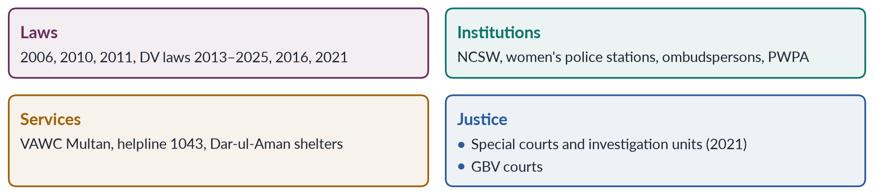
Figure 9 · Government initiatives against violence against women.

4. Services and courts
- The Violence against Women Centre in Multan (2017), set up under the Punjab Protection of Women against Violence Act 2016, is a one-stop centre for FIRs, medical examination, forensic evidence, legal aid and counselling.
- Helplines such as the Punjab Women Helpline 1043 and the federal 1099 human-rights helpline provide advice and rescue.
- Dar-ul-Aman shelters run by provincial social welfare departments give temporary refuge, although many are overcrowded and restrict residents' freedom.
- Special courts and Special Sexual Offences Investigation Units under the 2021 Act, and gender-based violence courts piloted in Punjab, aim to speed up trials and improve convictions.
- The Benazir Income Support Programme (2008), paid to women, strengthens their economic position at home.
- The Zainab Alert, Response and Recovery Act 2020 created a system for rapid response to missing and abused children.

5. Assessment
The state's initiatives are impressive on paper and have made violence a public, not private, matter: Pakistan now has laws against almost every major form of violence and a growing network of services. But enforcement lags. In 2024, conviction rates were about 0.5% for rape and honour killing (SSDO); police often refuse to register complaints; families force settlements; one-stop centres and shelters are too few and under-funded; and provincial capacity varies after the 18th Amendment (2010). Many women — 56% of those who suffered violence, according to the PDHS 2017–18 — never seek help at all. Laws such as the Punjab Act were also attacked as "un-Islamic" by religious parties, which slowed implementation. The priority now is not more initiatives but making existing ones work: centres in every district, trained police and prosecutors, faster courts, witness protection and public awareness.

Why this answer scores
- Organises initiatives into framework, laws, institutions, services and courts.
- Names each law and institution with its year — the facts examiners check.
- Ends with a balanced assessment backed by data on the enforcement gap.
- A grid figure gives the examiner the whole picture at a glance.

Answer 5 · Structural and Direct Violence against Women in Pakistan: The Case of Mukhtaran Mai (CSS 2019)
AT A GLANCE · CSS 2019 · Q7 · 20 MARKS
Explain the structural and direct forms of violence against women in Pakistani society by highlighting the case study of Mukhtaran Mai.

The answer map
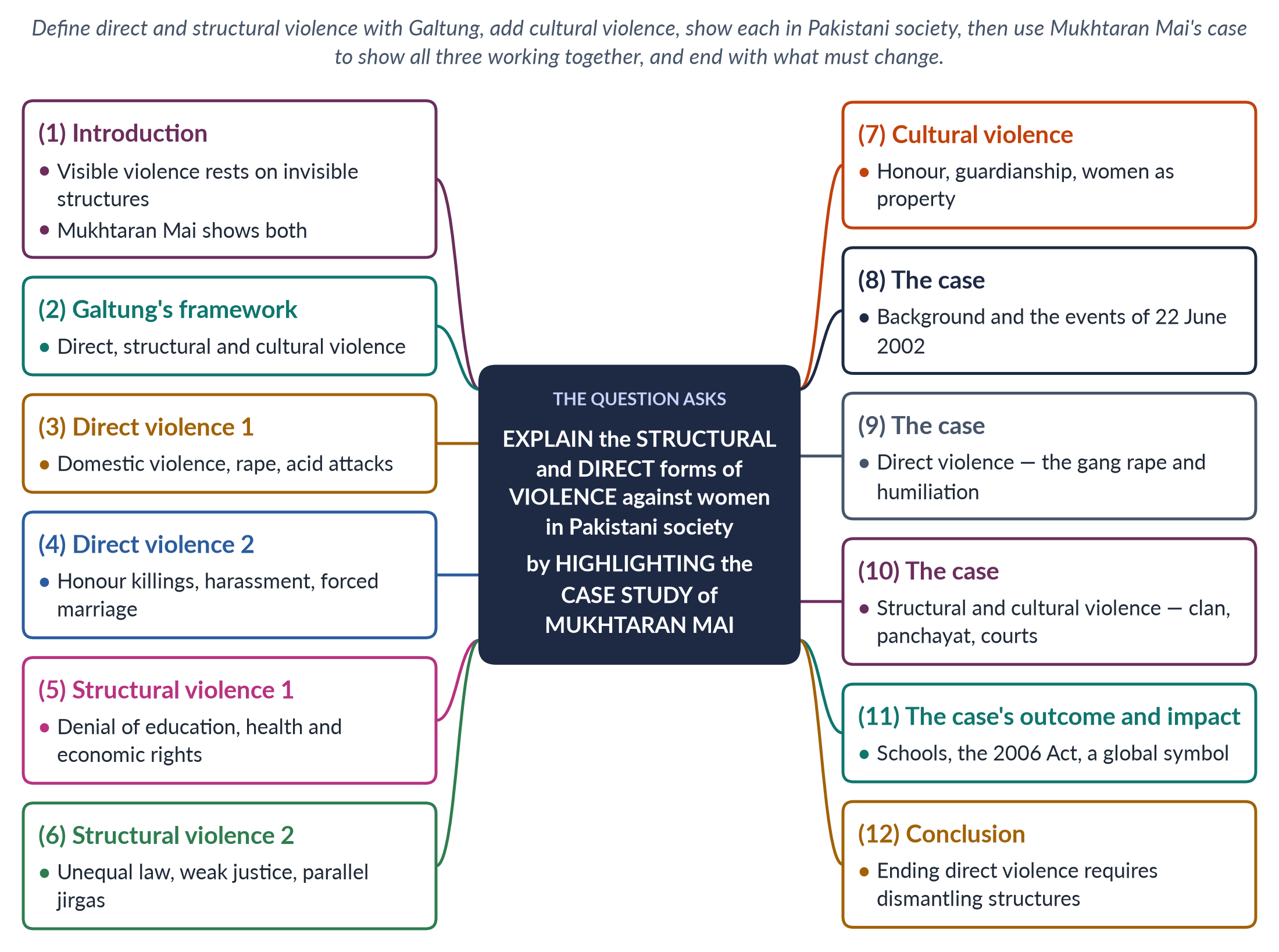
Figure 10 · The answer map: every branch is one numbered heading of the model answer below.

Decoding the question
"Explain" asks you to define and illustrate. "Structural and direct forms of violence" comes from Johan Galtung: define both, and add cultural violence for a stronger answer. "In Pakistani society" requires Pakistani examples and data. "By highlighting the case study of Mukhtaran Mai" means the case must be analysed through the framework — not just narrated.

The model answer

1. Introduction

i) Definition
The Norwegian peace scholar Johan Galtung (1969) distinguished direct violence — harm done by an identifiable person, such as a beating — from structural violence — harm built into the way society is organised, such as poverty or unequal laws, where no single person strikes a blow.

ii) The argument
In Pakistan, the visible direct violence that women suffer — beatings, rape, acid attacks, honour killings — rests on invisible structural foundations: denial of education and property, unequal laws, weak justice and parallel jirgas, all justified by cultural beliefs about honour. The case of Mukhtaran Mai (2002) shows all three working together.

2. Galtung's framework
Galtung defined violence as present whenever people's actual physical and mental realisation is held below their potential. Direct violence has an actor and a victim. Structural violence is "social injustice": unequal distribution of power and resources that shortens lives without a visible attacker. In 1990 he added cultural violence — the beliefs, religious interpretations, language and symbols that make the other two seem natural or right. Together they form a triangle: only the tip — direct violence — is visible, like the tip of an iceberg, while structural and cultural violence lie beneath the surface and keep producing it.

3. Direct violence 1: domestic violence, rape and acid attacks

i) Domestic violence
According to the PDHS 2017–18, 28% of ever-married women have experienced physical violence since age 15, and 34% spousal physical, sexual or emotional violence.

ii) Rape
In 2024, 5,339 rapes were reported, with a conviction rate of about 0.5% (SSDO). Gang rape is sometimes used as revenge.

iii) Acid attacks
Acid is thrown on women who refuse proposals or advances, leaving them blind and disfigured; the Acid Control and Acid Crime Prevention Act 2011 prescribes 14 years to life imprisonment.

4. Direct violence 2: honour killings, harassment and forced marriage
The Human Rights Commission of Pakistan recorded at least 405 honour killings in 2024. Women face sexual harassment at work, in the street and online, and forced marriage, abduction and vani — girls handed over to settle disputes. These are all acts with identifiable perpetrators: fathers, husbands, brothers, strangers, elders. In 2024 the SSDO recorded 32,617 reported cases of gender-based violence — and most violence is never reported.

5. Structural violence 1: denial of education, health and economic rights

i) Education
Female literacy is about 53% (Census 2023), and millions of girls are out of school — a denial of potential that no single person commits.

ii) Health
Maternal mortality of 186 per 100,000 live births (2019) means thousands of preventable deaths each year.

iii) Economy and property
Female labour-force participation is only 24.4%, and women are routinely denied their inheritance, leaving them dependent and vulnerable.

6. Structural violence 2: law, justice and parallel jirgas

i) Unequal laws
Under the Zina Ordinance (1979), a raped woman who could not prove her case risked prosecution for adultery; under the Qisas and Diyat law, honour killers were pardoned by their own families until the 2016 reform.

ii) Weak justice
Police refuse to register cases, investigations are poor, trials take years, and conviction rates are around 0.5%.

iii) Parallel justice
Jirgas and panchayats of male elders, outside the law, decide disputes and order punishments such as vani, swara and the killing of women declared kari. The Supreme Court has declared rights-violating jirgas illegal, yet they continue because formal justice is distant and slow.
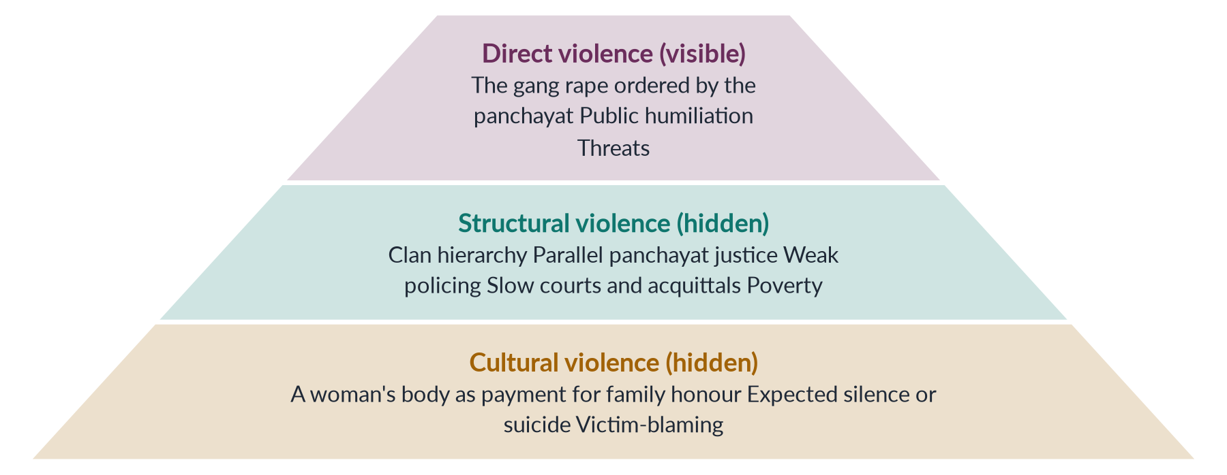
Figure 11 · Galtung's triangle applied to Mukhtaran Mai's case.

7. Cultural violence
The beliefs that sustain both: family honour (izzat, ghairat) located in women's bodies; the husband's right to "discipline"; daughters as "paraya dhan" (another's wealth); and misinterpretations of religion. These beliefs make violence appear as justice and structural inequality appear as tradition.

8. The case: background and events
Mukhtaran Mai belonged to the low-status Tatla clan of Meerwala, in Muzaffargarh district of South Punjab, where the powerful Mastoi clan dominated land and the village panchayat. In June 2002, her young brother Shakoor was accused of a relationship with a Mastoi woman. When Mukhtaran Mai went to the panchayat to apologise for her family, it ordered that she be gang-raped as "punishment". On 22 June 2002 four men raped her, and she was made to walk home before villagers.

9. The case: direct violence
The gang rape, the public humiliation and later threats to her family were direct violence: identifiable men committing identifiable crimes. Custom expected her to remain silent or to kill herself. Instead, with support from a local imam who condemned the crime in a sermon and from journalists, she reported it — an act of extraordinary courage for a poor, uneducated village woman facing a powerful clan.

10. The case: structural and cultural violence

i) Structural
The clan hierarchy allowed the Mastois to punish a weaker family; the panchayat acted as an illegal court; and the justice system failed her. An Anti-Terrorism Court sentenced six men to death in August 2002, but the Lahore High Court acquitted five in 2005, and the Supreme Court upheld those acquittals on 21 April 2011, leaving only Abdul Khaliq serving life imprisonment.

ii) Cultural
The idea that a woman's body could pay her family's "honour" debt, and officials' victim-blaming — President Musharraf's government even briefly barred her from travelling abroad in 2005 — reflect cultural violence.

11. The case's outcome and impact
Mukhtaran Mai turned tragedy into activism. With government compensation she founded the Mukhtar Mai Girls' Model School in Meerwala and the Mukhtar Mai Women's Welfare Organisation, and she became an international symbol of courage; her memoir, In the Name of Honor, appeared in 2006. Her case fed the national debate that produced the Protection of Women (Criminal Laws Amendment) Act 2006, and the Prevention of Anti-Women Practices Act 2011 later criminalised custom-based punishments such as vani.

12. Conclusion
Direct violence against Pakistani women — beatings, rapes, acid attacks and honour killings — is the visible tip of a pyramid whose base is structural inequality and cultural justification. Mukhtaran Mai's case shows all three: a gang rape (direct), ordered by a clan-controlled panchayat and left largely unpunished by the courts (structural), in the name of honour (cultural). Ending direct violence therefore requires dismantling the structures beneath it — girls' education, women's property, the end of parallel justice, and courts that convict.

Why this answer scores
- Defines direct, structural and cultural violence precisely (Galtung 1969, 1990).
- Gives Pakistani examples and data for each form, as "in Pakistani society" requires.
- Analyses Mukhtaran Mai's case through the framework rather than merely narrating it.
- A pyramid figure shows how the three forms rest on one another.

Answer 6 · The Power-and-Control Relationship in Gender-Based Violence (CSS 2020)
AT A GLANCE · CSS 2020 · Q7 · 20 MARKS
Comment on the power-and-control relationship in gender-based violence.

The answer map
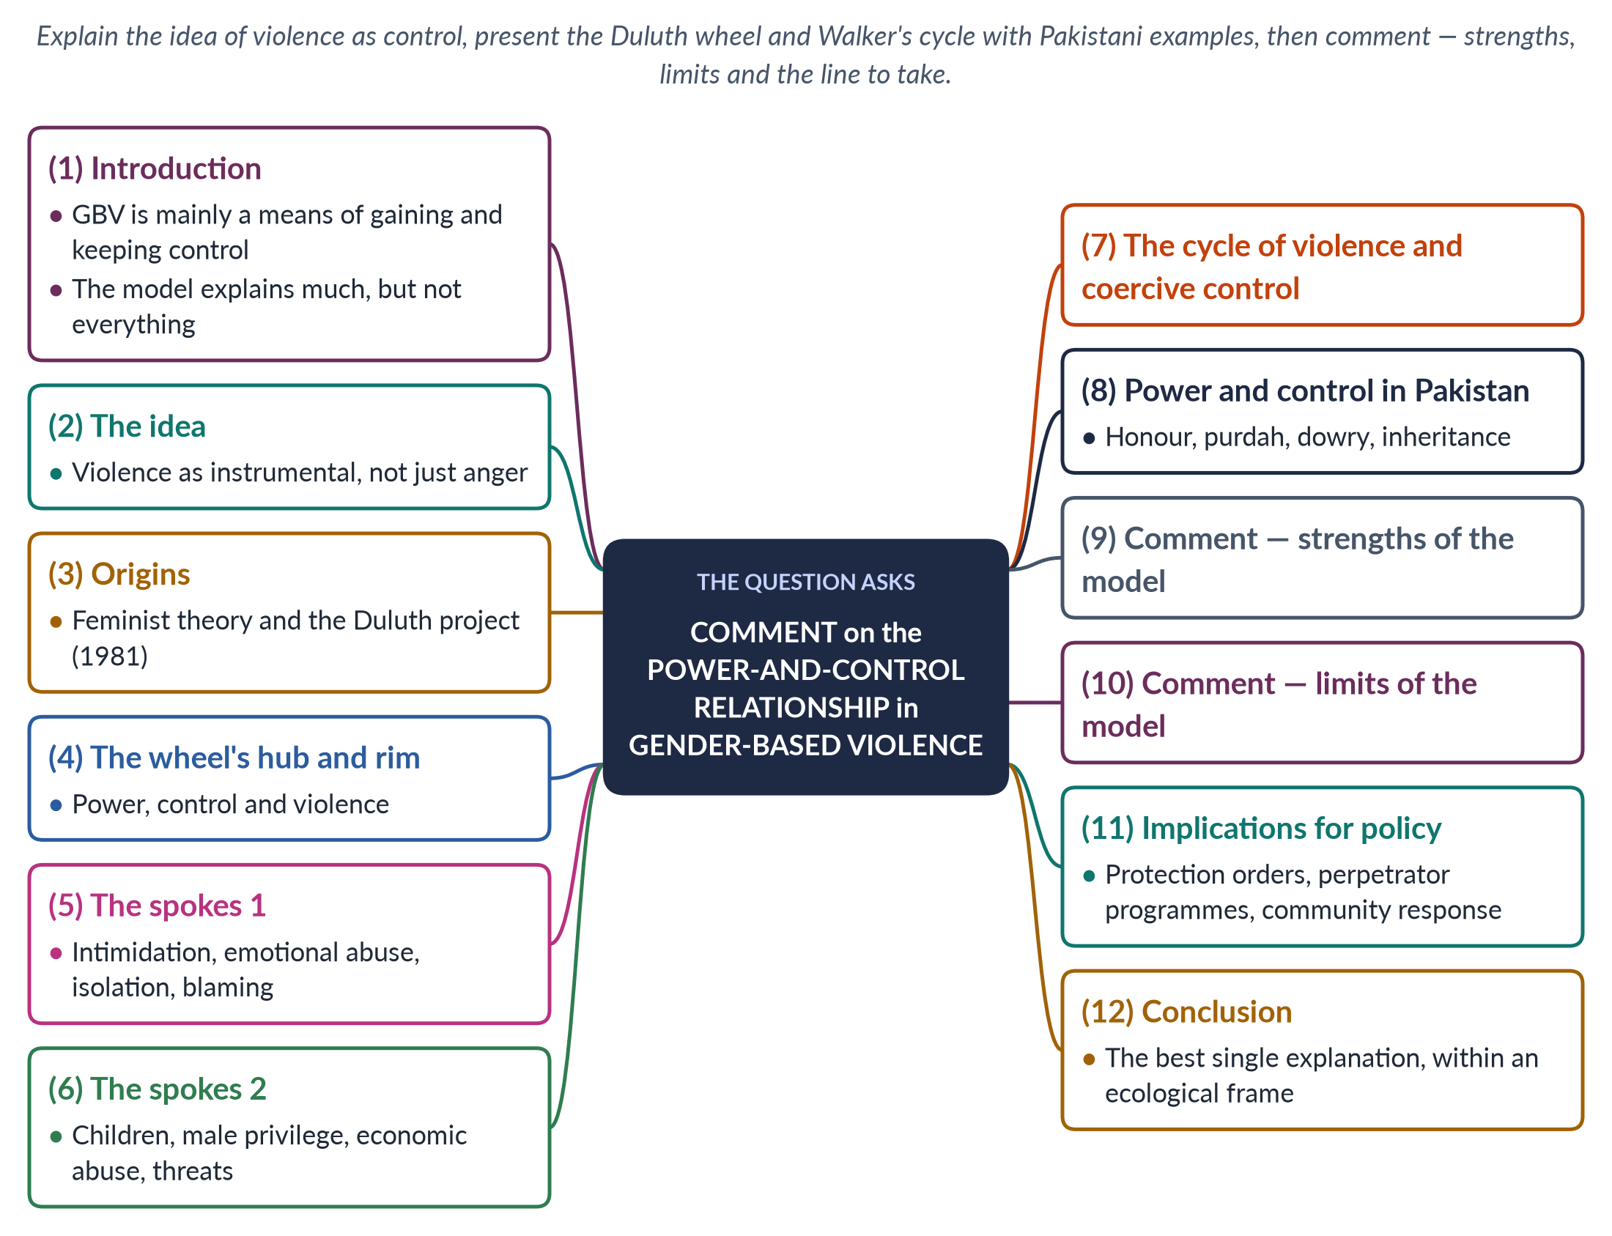
Figure 12 · The answer map: every branch is one numbered heading of the model answer below.

Decoding the question
"Comment on" asks you to explain and evaluate: what the power-and-control relationship means, how it works, and how far it explains gender-based violence. Use the Duluth Power and Control Wheel and Walker's cycle, apply them to Pakistan, and give strengths and limits before a reasoned judgement.

The model answer

1. Introduction

i) Definition
The power-and-control view holds that gender-based violence is not random or merely the product of anger, but a pattern of behaviour by which one person — usually a man — gains and maintains control over another, usually his partner or a female relative.

ii) The argument
This view, developed from survivors' own accounts, is the most convincing single explanation of gender-based violence: it explains why violence is selective, patterned and gendered, and why non-physical abuse matters. It fits Pakistan especially well, where honour codes give men control over women's choices. But it must be combined with structural and ecological explanations to be complete.

2. The idea: violence as instrumental
Feminist researchers noticed that most abusers are not violent everywhere — they rarely hit their bosses or colleagues — but direct violence at wives, daughters and sisters, the people they seek to control. Violence is therefore instrumental: a tool to obtain obedience over a woman's movement, money, friendships, sexuality and decisions. Even a single severe beating can control a woman for years, because the threat of repetition shapes everything she does — whom she meets, what she wears, how she spends money and whether she dares to complain.

3. Origins: feminism and the Duluth project
The classic feminist study, Violence Against Wives by R. Emerson Dobash and Russell Dobash (1979), showed that wife-beating expressed men's sense of authority and entitlement. In 1981 the Domestic Abuse Intervention Project in Duluth, Minnesota — with activists such as Ellen Pence and Michael Paymar — listened to women in support groups and drew the Power and Control Wheel, which became the most widely used tool in the world for understanding domestic abuse.

4. The wheel's hub and rim
At the hub of the wheel is power and control — the abuser's goal. Around it are spokes, the everyday tactics used to achieve it. Around the outside runs the rim of physical and sexual violence, which "holds the wheel together": the other tactics work because the woman knows that violence may follow if she resists.
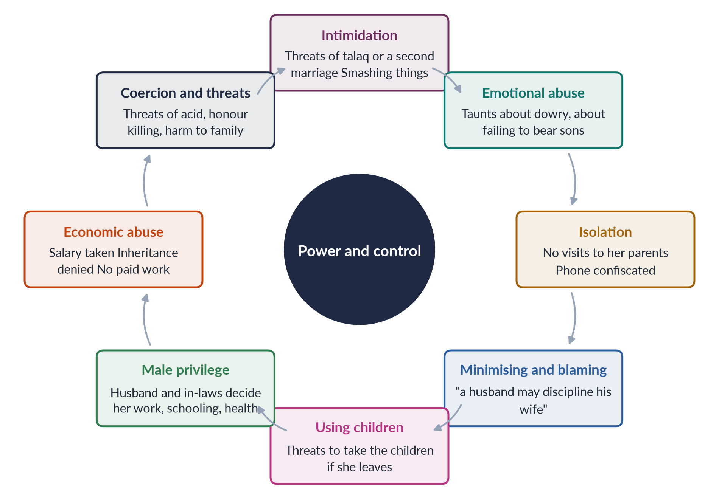
Figure 13 · The Duluth Power and Control Wheel, with Pakistani examples.

5. The spokes 1: intimidation, emotional abuse, isolation, blaming

i) Intimidation
Frightening looks, smashing objects and displaying weapons.

ii) Emotional abuse
Insults, humiliation and making a woman feel worthless or "mad".

iii) Isolation
Controlling whom she sees and where she goes, cutting her off from family and friends who might help her.

iv) Minimising, denying, blaming
"It was nothing", "you provoked me" — shifting responsibility to the victim.

6. The spokes 2: children, privilege, money, threats

i) Using children
Threatening to take the children or using them to relay threats.

ii) Male privilege
Treating her as a servant and making all major decisions.

iii) Economic abuse
Taking her money, preventing her from working, making her ask for every rupee — which makes leaving almost impossible.

iv) Coercion and threats
Threats to leave, divorce, harm her or her family, or to commit suicide if she leaves — forcing her to drop complaints.

7. The cycle of violence and coercive control
The American psychologist Lenore Walker, in The Battered Woman (1979), described a cycle: tension building, an acute battering incident, and a phase of "loving contrition" with apologies and promises, before tension builds again. The cycle explains why women stay — hope, fear and dependence. The British sociologist Evan Stark (2007) went further, describing coercive control — a pattern of isolation, surveillance and degradation that traps a woman like a hostage, even when physical assaults are rare.

8. Power and control in Pakistan

i) Honour
Honour killings, acid attacks and forced marriage punish women for exercising choice — the clearest expression of control.

ii) Purdah and mobility
Restrictions on leaving the house can become tools of isolation.

iii) Dowry and money
Taunts and violence over dowry, and the taking of women's earnings, are economic abuse.

iv) Inheritance
Denying daughters and sisters their share keeps property — and power — with men.
The Punjab Protection of Women against Violence Act 2016 recognises several of these tactics — economic abuse, psychological abuse and stalking — as violence, which reflects the power-and-control understanding.

9. Comment — strengths of the model
1. It explains why violence is selective and patterned, not random.
2. It explains why most victims are women and most perpetrators men — because of unequal gender power.
3. It shows that non-physical abuse — isolation, threats, economic control — is real abuse.
4. It fits honour-based violence in Pakistan, which punishes women's autonomy.
5. It has shaped practice worldwide: the Duluth "co-ordinated community response", protection orders and perpetrator programmes.

10. Comment — limits of the model
1. It focuses on intimate partners and may not explain violence by strangers, in conflict or by the state.
2. It may underplay individual factors such as alcohol, mental illness or childhood trauma, and structural factors such as poverty, unemployment and illiteracy, which Lori Heise's ecological model (1998) brings in.
3. Michael Johnson (1995) argued that not all partner violence is "intimate terrorism"; some is "situational couple violence" arising from conflict.
4. Perpetrator programmes based on it show mixed results.
5. It must be adapted to joint families in Pakistan, where in-laws — including mothers-in-law — as well as husbands exercise control, so the "abuser" may be a whole household.

11. Implications for policy
If violence is about control, then responses must restore women's autonomy and remove the abuser's power: protection and residence orders (as in the Punjab Act 2016), women's economic independence, safe shelters, and a co-ordinated response by police, courts, health workers and communities that refuses to treat abuse as a "family matter". Men's programmes, such as those of the Pakistani NGO Rozan, can challenge the belief that men are entitled to control women, and religious scholars can affirm that Islam forbids cruelty within marriage.

12. Conclusion
The power-and-control relationship lies at the heart of gender-based violence: violence is a tool men use to gain and keep control over women, and its threat governs women's lives even when blows are rare. The Duluth wheel and Walker's cycle make this visible, and they fit Pakistan's honour-based and economic forms of abuse closely. Yet the model is most powerful when placed inside an ecological framework that also addresses poverty, impunity and harmful norms. Ending violence means not only punishing assaults but dismantling the control they serve.

Why this answer scores
- Explains the model through the Duluth wheel and Walker's cycle, with named sources.
- Applies it to Pakistan (honour, purdah, dowry, inheritance, the Punjab Act).
- Comments with balanced strengths and limits, as the command word requires.
- A cycle figure reproduces the wheel with Pakistani examples.

Answer 7 · The Background of Sharmeen Obaid-Chinoy's Two Oscar-Winning Documentaries (CSS 2020)
AT A GLANCE · CSS 2020 · Q8 · 20 MARKS
Discuss the background of the two Oscar-winning documentaries by Sharmeen Obaid-Chinoy.

The answer map
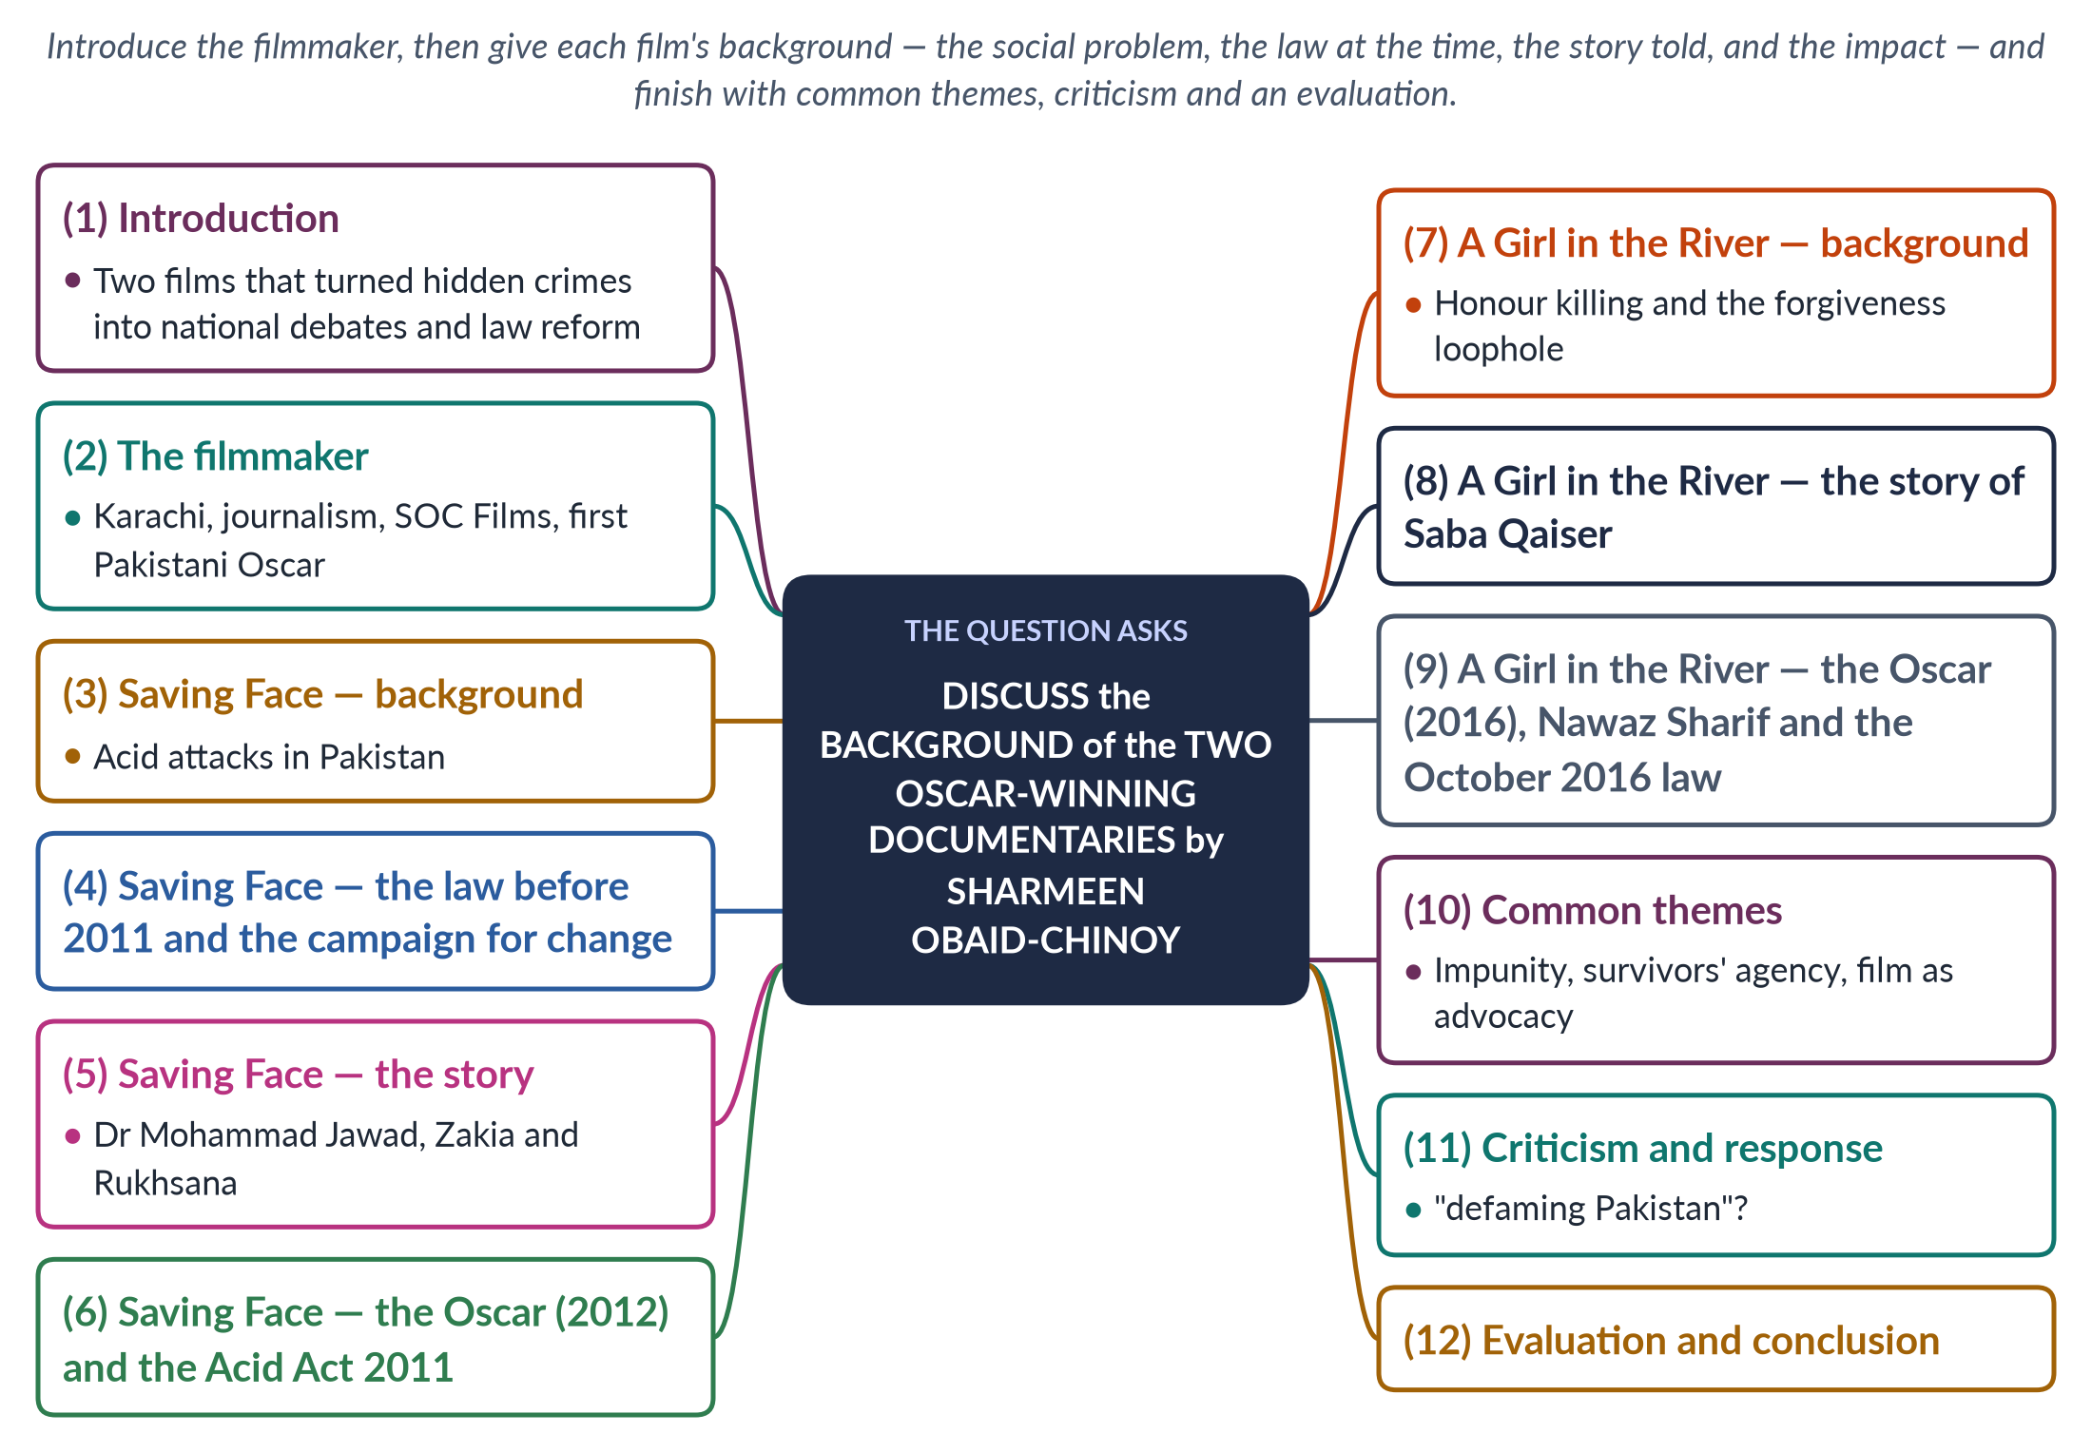
Figure 14 · The answer map: every branch is one numbered heading of the model answer below.

Decoding the question
"Discuss the background" asks for the context of each film — the social problem it addressed, the legal situation at the time, the story it told and why it mattered — not just a plot summary. The two films are Saving Face (Oscar 2012, acid attacks) and A Girl in the River: The Price of Forgiveness (Oscar 2016, honour killing). End with an evaluation of their impact.

The model answer

1. Introduction

i) Who she is
Sharmeen Obaid-Chinoy, a journalist and documentary filmmaker from Karachi, is the first Pakistani to win an Academy Award (Oscar) — and she has won two, both for documentaries about violence against women.

ii) The argument
Each film grew out of a specific background: a form of violence that was common but hidden, laws that failed to punish it, and survivors whose stories had not been told. By telling those stories to the world, the films turned hidden crimes into national debates and helped push the state towards law reform — though their own stories show that laws alone do not end violence.

2. The filmmaker
Born in Karachi in 1978, Sharmeen Obaid-Chinoy studied at Smith College and Stanford University in the United States. She began as a journalist and turned to documentary film to expose injustice. Her early films included Terror's Children (2002), about Afghan refugee children, and Pakistan: Children of the Taliban, which won an Emmy in 2010. Through her company, SOC Films, she has focused on stories of women, children and minorities.

3. *Saving Face* — background: acid attacks in Pakistan
In the 2000s, acid attacks became a growing crime in Pakistan, especially in parts of southern Punjab, where acid used in cotton processing and other industries was cheap and easily available. Attackers threw acid, usually on a woman's face, in revenge for refusing a marriage proposal or sexual advances, or in domestic and family disputes. Victims were left blind, disfigured and socially isolated; many could not work, marry or appear in public, and needed repeated, expensive surgery.

4. *Saving Face* — the law before 2011
Before 2011 there was no specific law on acid attacks: they were prosecuted as ordinary "hurt" under the Penal Code, with lighter penalties, and the sale of acid was unregulated. Perpetrators were rarely punished. Activists, the Acid Survivors Foundation and women legislators campaigned for a dedicated law, and a private member's bill moved through Parliament in 2011 — the period in which the film was made.

5. *Saving Face* — the story
Saving Face, co-directed with the American filmmaker Daniel Junge, follows Dr Mohammad Jawad, a British-Pakistani plastic surgeon who returned to Pakistan to perform reconstructive surgery on acid-attack survivors. It tells the stories of two women:
- Zakia, attacked by her husband, who pursues justice in court;
- Rukhsana, attacked by her husband and in-laws, who has to return to live with them because she has nowhere else to go.
The film shows both the cruelty of the attacks and the courage of survivors, doctors, lawyers and legislators working for change.

6. *Saving Face* — the Oscar and the Acid Act
Saving Face won the Academy Award for Best Documentary (Short Subject) in February 2012 — Pakistan's first Oscar. It coincided with the passage of the Acid Control and Acid Crime Prevention Act 2011, which added sections 336A and 336B to the Penal Code and set punishments of 14 years to life imprisonment and a minimum fine of one million rupees. The government awarded the filmmaker the Hilal-i-Imtiaz, and TIME named her among the world's most influential people.
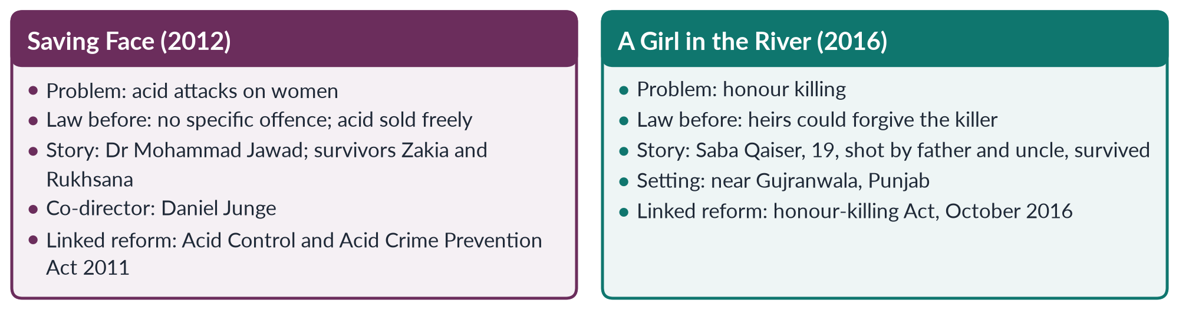
Figure 15 · Sharmeen Obaid-Chinoy's two Oscar-winning documentaries.

7. *A Girl in the River* — background: honour killing and the forgiveness loophole
Hundreds of women are killed each year in Pakistan in the name of honour — at least 405 in 2024, according to the Human Rights Commission of Pakistan. Under the Qisas* and *Diyat law (1990, made an Act in 1997), murder was compoundable: the victim's heirs could forgive the killer. In honour killings, the heirs were usually the killer's own family, so fathers and brothers who killed daughters and sisters were "forgiven" and freed. A bill to close this loophole, moved by Senator Sughra Imam in 2014, had stalled.

8. *A Girl in the River* — the story of Saba Qaiser
A Girl in the River: The Price of Forgiveness tells the story of Saba Qaiser, a 19-year-old from a village near Gujranwala, Punjab. In 2014 she married the man she loved against her family's wishes. Her father and uncle shot her in the head, put her in a sack and threw her into a river. Miraculously she survived and dragged herself to the bank. The film follows her recovery and her pursuit of justice — and the intense pressure from elders and the community that led her, in the end, to forgive her attackers, who were then released. Her father declared that he had done the right thing.

9. *A Girl in the River* — the Oscar and the 2016 law
The film won the Academy Award for Best Documentary (Short Subject) in February 2016. Prime Minister Nawaz Sharif hosted a screening and declared, "There is no honour in honour killing", promising to change the law. After the murder of Qandeel Baloch in July 2016, Parliament passed the Criminal Law (Amendment) (Offences in the name or pretext of Honour) Act in October 2016, under which a court must impose life imprisonment even if the family forgives the killer.

10. Common themes

i) Impunity
Both films show how families and communities shield perpetrators.

ii) Survivors' agency
Zakia, Rukhsana and Saba are not just victims; they resist, seek justice and rebuild their lives.

iii) Film as advocacy
Both films were made and screened at moments of legislative debate and were used to press for law reform.

iv) Two faces of Pakistan
Alongside cruelty, the films show Pakistani doctors, lawyers, activists and politicians working for change.

11. Criticism and response
Some critics in Pakistan accused her of "washing dirty linen in public" — tarnishing the country's image abroad by showing its worst problems to Western audiences — and of portraying Pakistani women only as victims. Her supporters reply that silence protects abusers, that the films highlight Pakistani reformers and survivors' courage, and that they produced concrete legal change at home. She has said her aim was to provoke debate inside Pakistan.

12. Evaluation and conclusion
Sharmeen Obaid-Chinoy's two Oscar-winning documentaries were rooted in specific backgrounds: the unpunished epidemic of acid attacks and the forgiveness loophole that freed honour killers. By telling the stories of Zakia, Rukhsana and Saba Qaiser, they brought global attention to hidden crimes and contributed to the Acid Act 2011 and the honour-killing Act 2016. Yet the films' own endings — Rukhsana returning to her abusers, Saba forced to forgive — show that enforcement and social change must follow law reform. Her work shows the power of media as a tool in the struggle against gender-based violence.

Why this answer scores
- Gives the background of each film — problem, law, story, impact — exactly as asked.
- Uses accurate names, dates and laws (Junge, Jawad, Zakia, Rukhsana, Saba Qaiser, 2011, 2016).
- Adds common themes, criticism and an evaluation, lifting it above narration.
- A compare figure sets the two films side by side.

Answer 8 · Gender-Based Violence Defined; Its Forms in Pakistan; Practical Strategies to Eradicate It (CSS 2023)
AT A GLANCE · CSS 2023 · Q8 · 20 MARKS
Define gender-based violence. Explain various forms of violence against women in Pakistan and devise practical strategies helpful in eradicating gender-based violence from our society.

The answer map
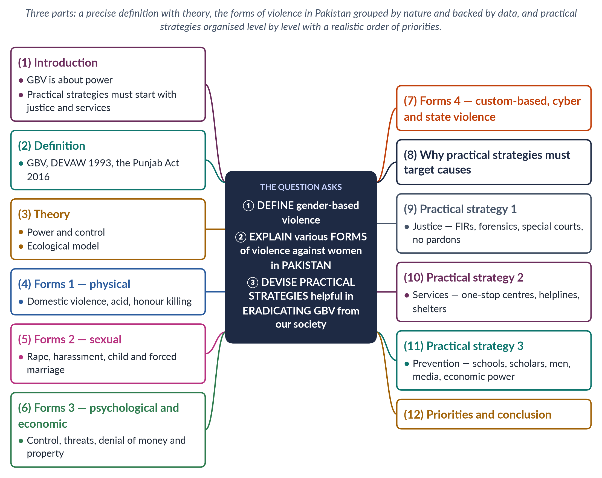
Figure 16 · The answer map: every branch is one numbered heading of the model answer below.

Decoding the question
Three parts. "Define" — give a precise, sourced definition. "Explain various forms… in Pakistan" — classify and illustrate with Pakistani data and cases. "Devise practical strategies" — design a plan that can be implemented, with concrete measures and priorities. Avoid repeating 2016 and 2017 answers word for word: here the emphasis is on definition and practicality.

The model answer

1. Introduction

i) Definition in brief
Gender-based violence (GBV) is harm inflicted on a person because of their gender, arising from unequal power between women and men.

ii) The argument
In Pakistan GBV takes physical, sexual, psychological, economic and custom-based forms, at home, in the community, at work and online. Because these forms share one root — men's power and control, protected by impunity — practical strategies must begin with justice and services, which can be delivered now through existing laws, and build towards long-term prevention that changes norms.

2. Definition
The UN Declaration on the Elimination of Violence against Women (1993) defines violence against women as "any act of gender-based violence that results in, or is likely to result in, physical, sexual or psychological harm or suffering to women, including threats of such acts, coercion or arbitrary deprivation of liberty, whether occurring in public or in private life". In Pakistan, the Punjab Protection of Women against Violence Act 2016 defines violence to include domestic violence, sexual violence, psychological abuse, economic abuse, stalking and cybercrime. Worldwide, about 1 in 3 women experience physical or sexual violence (WHO, 2021).

3. Theory
Feminist theory explains GBV as a means of power and control: the Duluth Power and Control Wheel (1981) shows how intimidation, isolation, economic abuse and threats, backed by physical violence, keep women subordinate. Social learning theory shows that violence is learned and continues when unpunished. Lori Heise's ecological model (1998) places causes at four levels — individual, relationship, community and society — and so shows where strategies must act.

4. Forms 1 — physical violence

i) Domestic violence
The PDHS 2017–18 found that 28% of ever-married women had experienced physical violence since age 15; 34% had experienced spousal physical, sexual or emotional violence.

ii) Acid attacks
Acid is thrown on women who refuse proposals or advances, blinding and disfiguring them.

iii) Honour killing
At least 405 honour killings were recorded in 2024 (HRCP), and the SSDO counted 547 with a conviction rate of about 0.5%.

5. Forms 2 — sexual violence

i) Rape
5,339 rapes were reported in 2024. High-profile cases — the rape and murder of Zainab Ansari in Kasur (2018) and the motorway gang rape (2020) — led to the Zainab Alert Act 2020 and the Anti-Rape (Investigation and Trial) Act 2021.

ii) Harassment
Sexual harassment at work, in universities, on transport and online is widespread despite the 2010 workplace law and Section 509 PPC.

iii) Child and forced marriage
Marriage before 18, or without consent, exposes girls to sexual violence and ends their education; only Sindh (2013) and Islamabad (2025) have fixed the minimum age at 18.

6. Forms 3 — psychological and economic violence

i) Psychological violence
Threats of divorce, insults, isolation from family, confiscation of phones and constant surveillance cause depression and sometimes suicide.

ii) Economic violence
Taking a woman's earnings or dowry, forbidding her to work, and denying her inheritance keep her dependent — and dependence traps her in violence.

7. Forms 4 — custom-based, cyber and state violence

i) Custom-based
Vani and swara, marriage to the Qur'an and forced marriage, often ordered by jirgas, were criminalised by the Prevention of Anti-Women Practices Act 2011.

ii) Cyber violence
Blackmail with private images and online harassment are covered by PECA 2016; online visibility has also triggered killings — of Qandeel Baloch (2016) and the 17-year-old Sana Yousaf (2025).

iii) State violence
Custodial abuse and police refusal to register cases make the state itself a site of violence.
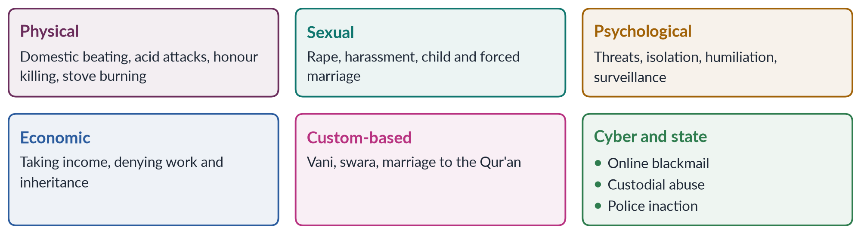
Figure 17 · The forms of violence against women in Pakistan.

8. Why practical strategies must target causes
A strategy is practical only if it addresses why violence continues. The evidence points to three causes: patriarchal norms that justify control, women's economic dependence, and impunity — conviction rates of about 0.5% for rape and honour killing in 2024 (SSDO). Pakistan already has laws against almost every form above; the practical task is to make them work.

9. Practical strategy 1: justice

i) Registration and investigation
Make FIR registration compulsory, with penalties for officers who refuse; recruit more women police; fully staff the Special Sexual Offences Investigation Units created by the 2021 Act.

ii) Evidence and courts
Build DNA laboratories and train women medico-legal officers; extend special courts with fast, in-camera trials; protect witnesses.

iii) No pardons
Make honour killings and other GBV crimes fully non-compoundable, and prosecute jirga members who order violence.

10. Practical strategy 2: services
Replicate the Violence against Women Centre, Multan (2017) — where a woman can register a case, receive medical examination, legal aid and counselling in one place — in every district. Keep helplines such as 1043 staffed around the clock; make shelters safe and dignified; enforce protection, residence and monetary orders under the Punjab Act 2016 and other provincial laws. Use Lady Health Workers, who visit homes, to identify and refer survivors.

11. Practical strategy 3: prevention

i) Schools
Teach respect, consent and non-violent conflict resolution; keep girls in school, which delays marriage.

ii) Scholars and media
Ask religious scholars to declare in Friday sermons that honour killing is murder and that forced marriage and denial of inheritance are un-Islamic; use television dramas and the 16 Days of Activism to model respectful relationships.

iii) Men and boys
Expand programmes, like those of Rozan, that challenge the idea that violence proves manhood.

iv) Economic power
Enforce the 2020 property law, expand women's jobs and cash transfers through BISP, and set the minimum marriage age at 18 everywhere.
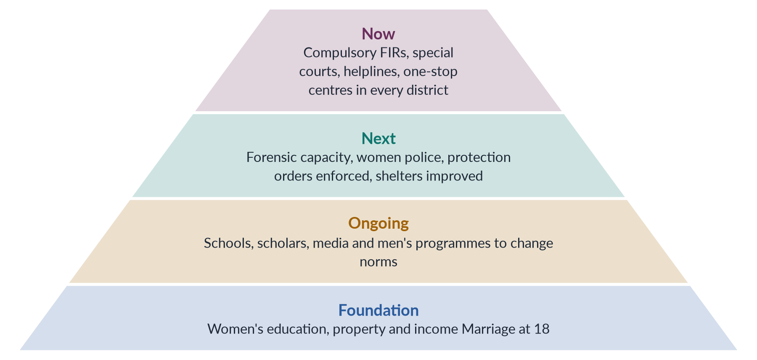
Figure 18 · Practical strategies in order of priority — quick wins at the top, long-term change at the base.

12. Priorities and conclusion

i) Priorities
Begin with justice and services — they use existing laws and staff and can show results quickly. Build prevention in parallel, because it takes a generation. Measure progress through a national GBV database that publishes cases and convictions every year.

ii) Conclusion
Gender-based violence is harm rooted in unequal gender power. In Pakistan it takes physical, sexual, psychological, economic, custom-based and cyber forms. The most practical strategy is to end impunity through effective policing and courts, to bring services within every woman's reach, and to change norms through schools, mosques, the media and men themselves — while giving women the economic independence that makes resistance possible. Pakistan has the laws; it now needs the will to enforce them.

Why this answer scores
- Gives a sourced definition (DEVAW 1993; Punjab Act 2016) and a theoretical frame.
- Explains the forms by category with up-to-date data and cases.
- Strategies are genuinely practical — prioritised, costed in existing institutions, and measurable.
- A grid and a pyramid figure organise forms and priorities.

Answer 9 · Gender-Based Violence, Its Forms under the Punjab Act 2016, and Its Consequences for Women (CSS 2024)
AT A GLANCE · CSS 2024 · Q6 · 20 MARKS
What is gender-based violence? What forms of gender-based violence are given in the Punjab Protection of Women Against Violence Act 2016? What are the consequences of gender-based violence for women?

The answer map
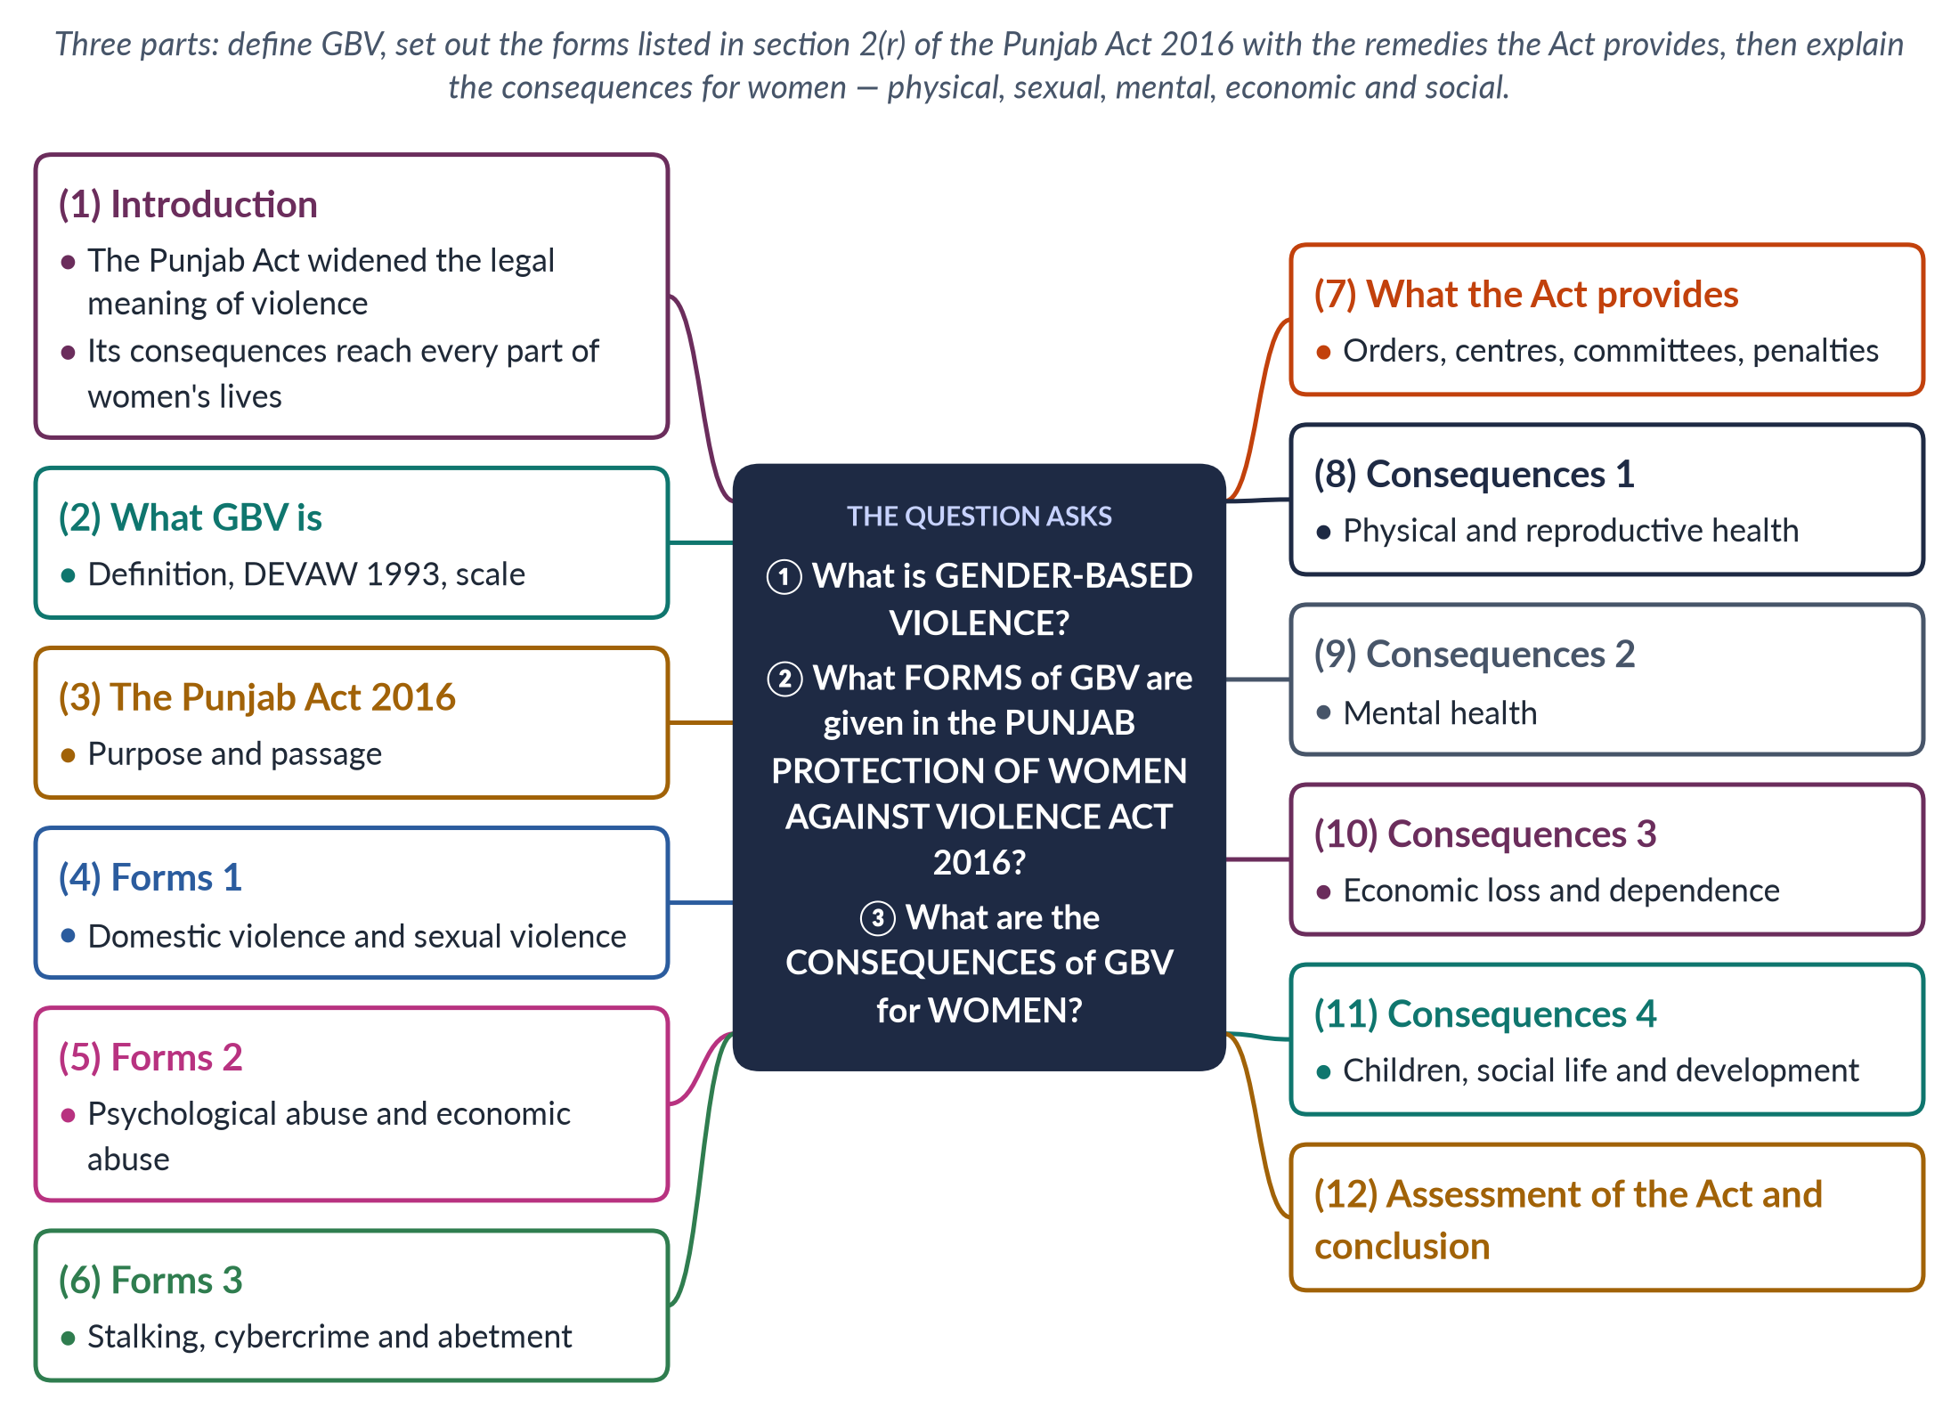
Figure 19 · The answer map: every branch is one numbered heading of the model answer below.

Decoding the question
Three parts. "What is gender-based violence?" — a precise definition. "What forms… are given in the Punjab Protection of Women against Violence Act 2016?" — the examiner wants the statutory list in section 2(r): abetment of an offence, domestic violence, sexual violence, psychological abuse, economic abuse, stalking and cybercrime — each explained. "Consequences for women" — the effects on women's health, minds, livelihoods and lives.

The model answer

1. Introduction

i) Definition in brief
Gender-based violence is harm directed at a person because of their gender, rooted in unequal power between women and men.

ii) The argument
The Punjab Protection of Women against Violence Act 2016 was a landmark because it widened the legal meaning of violence beyond physical assault to include psychological and economic abuse, stalking and cybercrime, and created a system of protection, relief and rehabilitation. Its breadth reflects the reality that GBV harms women in every part of their lives — their bodies, minds, incomes, children and place in society.

2. What GBV is
UN agencies define GBV as harmful acts directed at an individual based on their gender, rooted in gender inequality, the abuse of power and harmful norms. The UN Declaration on the Elimination of Violence against Women (1993) defines violence against women as any act of gender-based violence resulting in physical, sexual or psychological harm, including threats, coercion or deprivation of liberty, in public or private life. About 1 in 3 women worldwide experience physical or sexual violence (WHO, 2021); in Pakistan, 28% of ever-married women have experienced physical violence since age 15 (PDHS 2017–18).

3. The Punjab Act 2016: purpose and passage
The Punjab Assembly passed the Act on 24 February 2016, and it was published on 29 February 2016. Its stated aim is "to establish an effective system of protection, relief and rehabilitation of women against violence". It relies on Article 25 of the Constitution, which allows special provision for women. It is mainly a civil protection law: rather than creating new crimes, it gives women court orders and services to stop violence and rebuild their lives.

4. Forms 1: domestic violence and sexual violence
Section 2(r) defines violence as "any offence committed against the human body of the aggrieved person including abetment of an offence, domestic violence, sexual violence, psychological abuse, economic abuse, stalking or a cybercrime".

i) Domestic violence
Violence committed by a person with whom the woman lives or has lived in a house, when they are related by blood, marriage or adoption — for example, beating by a husband, brother or father-in-law.

ii) Sexual violence
Sexual assault and abuse, including within the household — an important recognition in a society where sexual abuse at home is rarely discussed.

5. Forms 2: psychological abuse and economic abuse

i) Psychological abuse
The Act explains psychological violence as psychological deterioration — such as anorexia, a suicide attempt or clinically proven depression — resulting from the defendant's oppressive behaviour or from limiting the woman's freedom of movement, certified by a panel of psychologists.

ii) Economic abuse
Economic abuse means denial of food, clothing and shelter in a domestic relationship in accordance with the defendant's income, or taking away the woman's income without her consent.

6. Forms 3: stalking, cybercrime and abetment

i) Stalking
Persistently following, watching or contacting a woman so as to cause fear.

ii) Cybercrime
Offences committed through electronic means — online harassment, blackmail with images, fake profiles.

iii) Abetment
Helping or encouraging an offence against a woman — for example, in-laws who incite a husband.
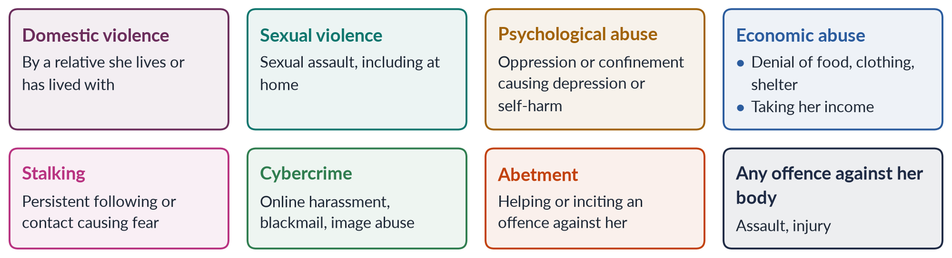
Figure 20 · The forms of violence listed in section 2(r) of the Punjab Act 2016.

7. What the Act provides
1. Court orders: a complaint to the Family Court, decided within 90 days, may result in an interim order; a protection order (no contact, stay away, move out of the house, surrender weapons and, for grave violence, a GPS ankle or wrist bracelet); a residence order (she cannot be evicted and may stay in the house or a shelter); and a monetary order (compensation for economic abuse, lost earnings, medical costs and maintenance).
2. Institutions: a toll-free helpline, District Women Protection Committees, Women Protection Officers, shelter homes and Protection Centres — "Violence against Women Centres" — the first of which opened in Multan in 2017.
3. Penalties: breach of an order is punishable by up to one year's imprisonment (up to two years for repeat breach); a false complaint by up to three months or a fine.

8. Consequences 1: physical and reproductive health
GBV causes injuries — bruises, fractures, burns — and sometimes disability, disfigurement or death: worldwide about 51,100 women and girls were killed by partners or family members in 2023 (UNODC and UN Women). Violence during pregnancy causes miscarriage and low birth weight; sexual violence causes unwanted pregnancy, unsafe abortion and sexually transmitted infections; early and forced marriage contribute to obstetric fistula and maternal death.

9. Consequences 2: mental health
Women who experience partner violence are almost twice as likely to suffer depression (WHO). Survivors experience anxiety, post-traumatic stress, low self-esteem, sleep and eating disorders, and suicidal thoughts — the very outcomes the Punjab Act names in its definition of psychological violence. Many live in constant fear, which damages their ability to work, study and care for their children.

10. Consequences 3: economic loss and dependence
Violence causes lost work days and lost jobs; economic abuse takes away women's income; fear of harassment keeps women out of jobs, colleges and public transport — one reason why female labour-force participation is only 24.4%. Women who leave violent homes often fall into poverty, especially when denied inheritance or maintenance, and dependence in turn makes it harder to escape further violence.

11. Consequences 4: children, social life and development

i) Children
Children who witness violence suffer trauma and poor schooling, and may repeat the pattern as adults — boys as abusers, girls as victims.

ii) Social life
Survivors face stigma, isolation and restrictions on movement; fear limits women's participation in public life and politics.

iii) Silence
56% of women who experienced violence never sought help (PDHS 2017–18).

iv) Development
Globally, violence against women is estimated to cost around 2% of world GDP, and it undermines progress on health, education, work and justice — SDGs 3, 4, 5, 8 and 16.
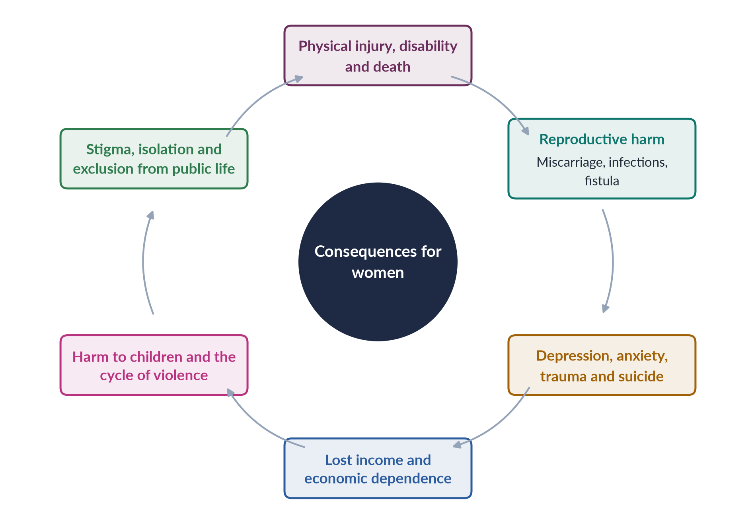
Figure 21 · The consequences of gender-based violence for women.

12. Assessment of the Act and conclusion

i) Assessment
The Act was progressive — the first Pakistani law to recognise psychological and economic abuse, stalking and cybercrime — and its one-stop centres brought police, doctors and lawyers under one roof. But religious parties and the Council of Islamic Ideology attacked it as "un-Islamic"; its mediation provisions risk pushing women back into abusive homes; and implementation has been slow, with few centres beyond Multan and limited awareness among women.

ii) Conclusion
Gender-based violence is harm rooted in unequal gender power. The Punjab Act 2016 recognises its many forms — domestic, sexual, psychological, economic, stalking and cyber — and offers women protection, residence and monetary orders. Its breadth is justified by the consequences of GBV, which damage women's bodies, minds, incomes, children and social lives. The Act's promise will be fulfilled only when its centres, officers and courts reach every woman in Punjab.

Why this answer scores
- Gives the exact statutory list of forms from section 2(r) and explains each.
- Adds what the Act provides — orders, institutions, penalties — showing real knowledge of the law.
- Covers consequences comprehensively, with WHO, UNODC and PDHS evidence.
- A grid and a cycle figure summarise the forms and the consequences.

Answer 10 · The Root Causes of Gender-Based Violence and How They Intersect in Pakistan (CSS 2025)
AT A GLANCE · CSS 2025 · Q2 · 20 MARKS
What are the root causes that lead to gender-based violence? How do these factors intersect and perpetuate violence against women in Pakistan?

The answer map
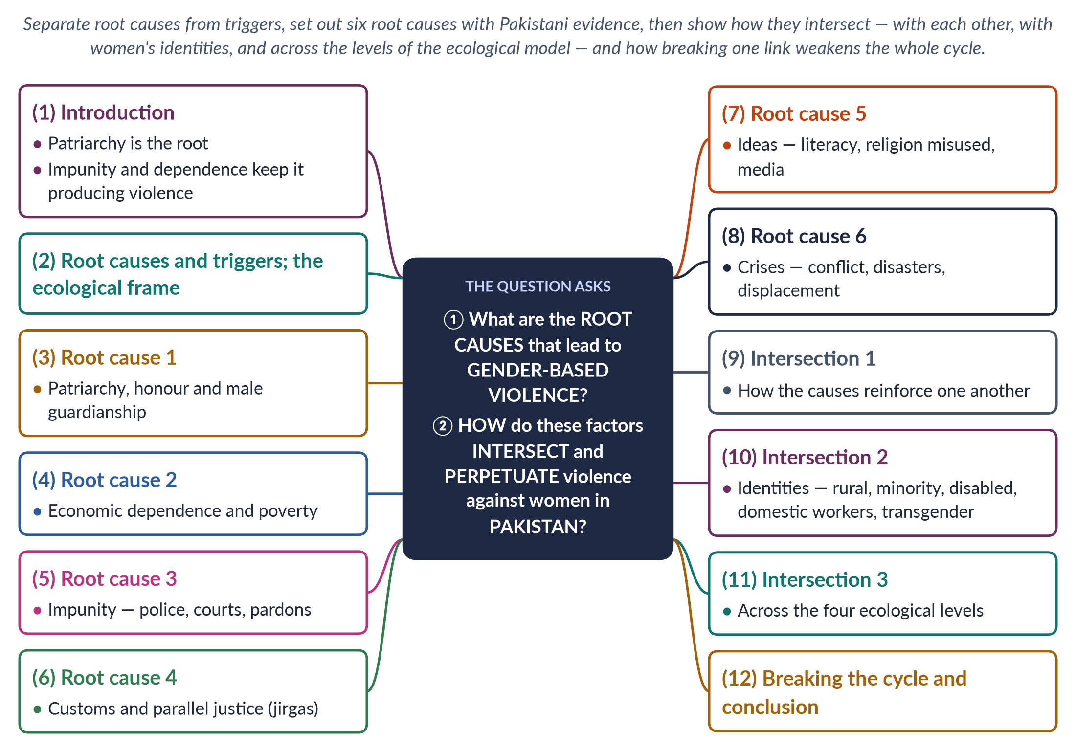
Figure 22 · The answer map: every branch is one numbered heading of the model answer below.

Decoding the question
Two parts. "Root causes" asks for the deep conditions that make GBV common and gendered — not just triggers such as a quarrel. "How do these factors intersect and perpetuate" is the analytical core: show how causes reinforce one another, how they combine with women's identities (intersectionality), and how they sustain violence over time. A cycle figure is ideal.

The model answer

1. Introduction

i) Definition
Gender-based violence is harm directed at a person because of their gender, rooted in unequal power between women and men; the UN and WHO identify gender inequality and harmful social norms as its root causes everywhere.

ii) The argument
In Pakistan, the root of GBV is a patriarchal social order that places family honour in women's bodies and authority in men's hands. Two further causes — women's economic dependence and the near-total impunity of perpetrators — allow that root to keep producing violence, while customs, ideas and crises add to it. These causes do not act separately: they intersect, reinforce one another and fall hardest on women who are poor, rural or from minorities, creating a self-perpetuating cycle.

2. Root causes and triggers
A root cause explains why violence is common and directed at women across society; a trigger explains why it erupts in a particular case — a dowry dispute, a job loss, drug use, a daughter's choice of husband. Lori Heise's ecological model (1998) organises causes at four levels — individual, relationship, community and society — and shows that violence results from their interaction. Feminist theory adds that violence is a means of power and control.

3. Root cause 1: patriarchy, honour and guardianship

i) Male authority
Many Pakistanis believe a husband may "discipline" his wife; in the PDHS 2017–18, large shares of women and men said wife-beating was justified in some circumstances.

ii) Honour
A family's izzat is believed to depend on its women's chastity and obedience, so any perceived breach — marrying by choice, seeking divorce, appearing on social media — can be punished, even by death. At least 405 honour killings were recorded in 2024 (HRCP).

iii) Son preference and control of marriage
Daughters are seen as "paraya dhan"; forced marriage and watta satta deny women choice, although the Supreme Court held in Saima Waheed (2004) that an adult woman may marry without a guardian's consent.

4. Root cause 2: economic dependence and poverty
Female labour-force participation is only 24.4% (LFS 2024–25), and women rarely own land or receive their inheritance. A woman without income or property cannot easily leave an abusive home. Poverty and unemployment add stress, dowry demands and conflict over money — triggers that, as resource theory (Goode, 1971) predicts, raise the risk of violence when men cannot assert authority in other ways.

5. Root cause 3: impunity
The most powerful sustaining cause is the near-certainty that perpetrators will not be punished. In 2024, the Sustainable Social Development Organization found conviction rates of about 0.5% for rape and honour killing, 1.3% for domestic violence and 0.1% for kidnapping; in Punjab, 225 honour killings produced just two convictions. Police refuse or delay FIRs, investigations lack forensic evidence, families pressure victims to withdraw, and trials take years. Until 2016, honour killers could be pardoned by their own relatives — and even after reform, the acquittal of Qandeel Baloch's brother in 2022 showed how settlements still free killers.

6. Root cause 4: customs and parallel justice
Jirgas and panchayats of male elders, outside the law, order vani and swara (girls given in settlement), declare women kari and approve their killing, and in the Mukhtaran Mai case (2002) ordered a gang rape as "punishment". In 2025, a couple were shot dead in Degari, Balochistan, allegedly on a tribal chief's orders. The Prevention of Anti-Women Practices Act 2011 criminalised these customs, but parallel justice persists where state courts are distant, slow and costly.

7. Root cause 5: ideas — literacy, religion and media
Female literacy is about 53%, and many women do not know their rights. Social learning theory shows that boys who see their fathers beat their mothers learn that violence is acceptable. Some clerics and elders misuse religion to justify beating, child marriage or honour killing, though mainstream scholars reject honour killing as murder. Some television dramas romanticise controlling husbands, and social media spreads harassment.

8. Root cause 6: crises
Militancy brought attacks on girls' schools and on Malala Yousafzai (2012); displacement exposes women to exploitation; the 2022 floods disrupted protection systems and raised the risk of early marriage. Research worldwide shows violence against women rises during crises, including the COVID-19 lockdowns of 2020.
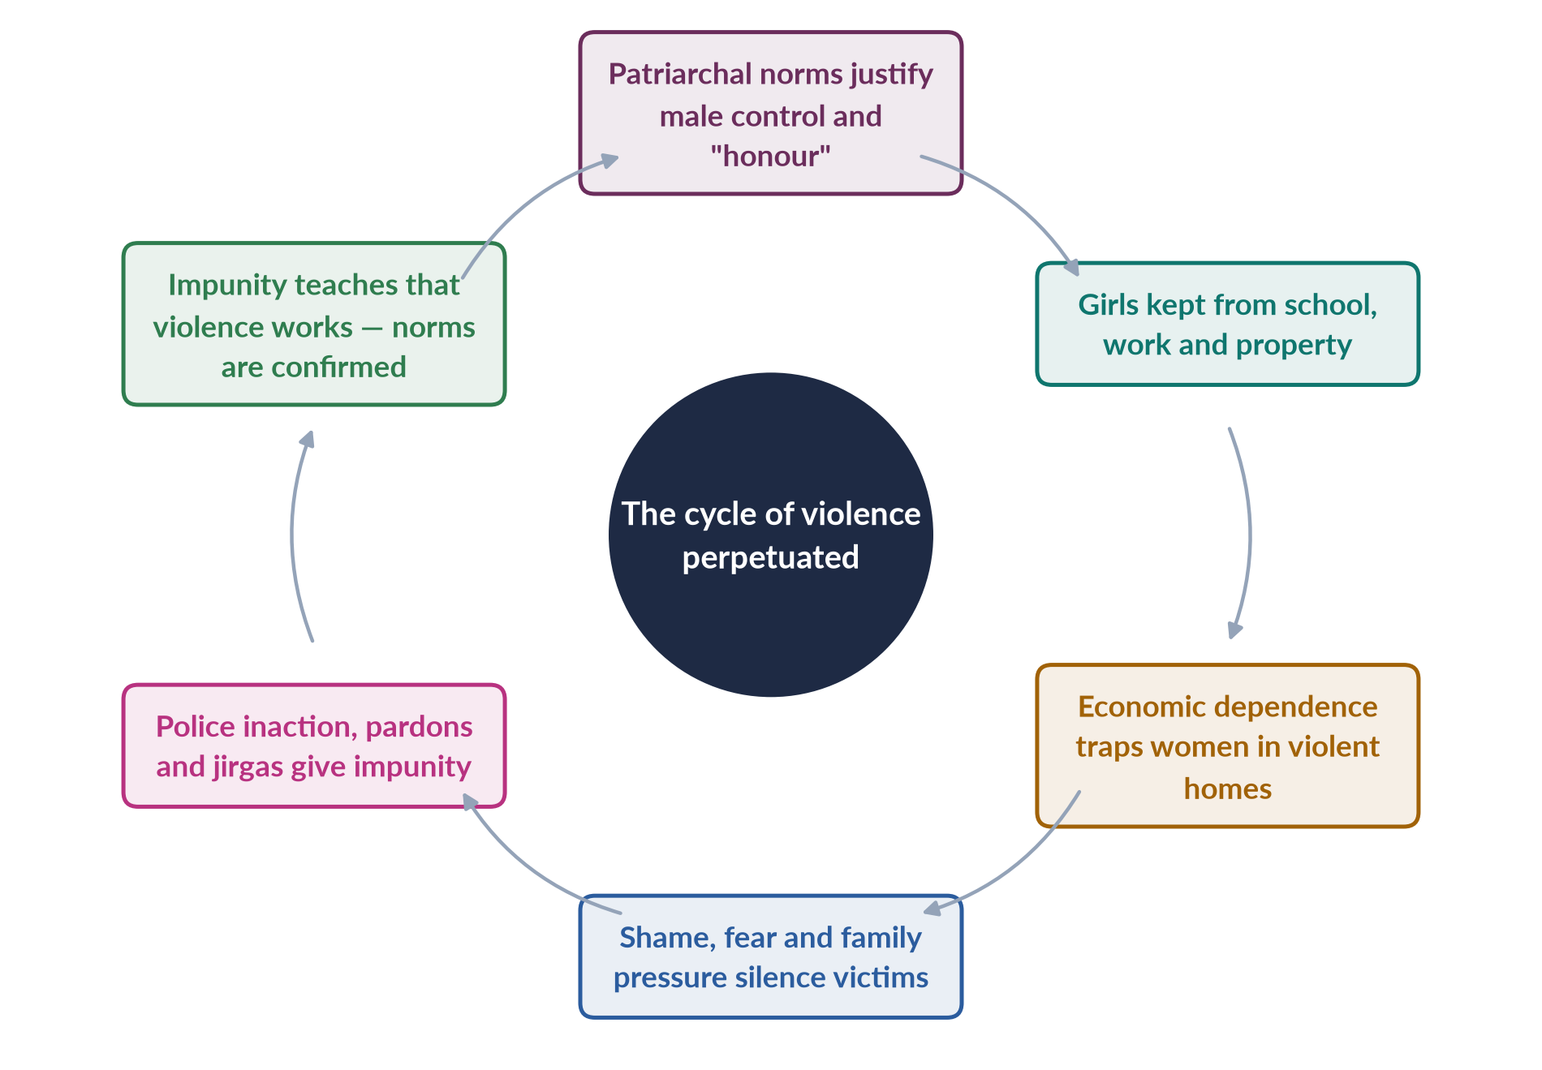
Figure 23 · How the root causes intersect and perpetuate violence against women in Pakistan.

9. Intersection 1: how the causes reinforce one another

i) Norms and economy
Honour norms keep women at home and out of paid work; economic dependence then keeps them silent.

ii) Economy and law
Poor women cannot afford lawyers or travel to courts, while abusers with money and connections can buy settlements.

iii) Law and custom
Where courts fail, jirgas fill the gap — and their judgements reflect patriarchal norms.

iv) Ideas and institutions
Police officers who share the belief that "family matters" are private refuse to act, turning cultural attitudes into institutional impunity.
The result is a self-reinforcing cycle: norms justify control, control produces violence, impunity confirms that violence works, and the norms are strengthened.

10. Intersection 2: identities
Using intersectionality (Kimberlé Crenshaw, 1989, 1991), the causes fall hardest on women who face several disadvantages at once:
- rural and poor women, far from police and courts and dependent on landlords and jirgas;
- Hindu and Christian girls, reported each year to be abducted, forcibly converted and married, especially in Sindh and Punjab;
- women with disabilities, more vulnerable to abuse and less able to report;
- domestic workers, often young girls, abused in employers' homes;
- khawaja siras (transgender persons), facing violence despite the Transgender Persons (Protection of Rights) Act 2018.
For these women, gender combines with class, religion, disability or gender identity, so violence is more likely and justice less reachable.

11. Intersection 3: across the ecological levels
Table 2 · Root causes at the four levels of the ecological model.
Level | Causes in Pakistan
Society | Patriarchal norms and honour codes; impunity; misused religion; crises
Community | Jirgas and panchayats; poverty and unemployment; isolation of women
Relationship | Husband's control of money; joint-family pressure; dowry disputes; forced marriage
Individual | Witnessing violence in childhood; low education; drug use; belief in male authority

A husband who saw his father beat his mother (individual), who controls the household's money (relationship), in a village where jirgas settle disputes (community), in a society that tolerates "disciplining" wives and rarely punishes violence (society), is far more likely to be violent — and far less likely to face consequences.

12. Breaking the cycle and conclusion

i) Breaking the cycle
Because the causes reinforce one another, breaking any link weakens the whole: ending impunity through compulsory FIRs, forensic evidence, special courts and non-compoundable offences; economic independence through jobs, inheritance and cash transfers to women; and changing norms through schools, religious scholars, the media and work with men and boys.

ii) Conclusion
The root cause of gender-based violence in Pakistan is a patriarchal order that ties honour to women's bodies and authority to men. Economic dependence, impunity, parallel justice, harmful ideas and crises intersect with it — and with women's class, religion and disability — to create a cycle that perpetuates violence across generations. Only a strategy that attacks norms, dependence and impunity together can break it.

Why this answer scores
- Distinguishes root causes from triggers and uses the ecological model.
- Gives six root causes with current Pakistani evidence (PDHS, SSDO, HRCP, cases).
- Answers "intersect" at three levels — causes, identities and ecological levels.
- A cycle figure shows how violence is perpetuated.

Answer 11 · Malala Yousafzai's Achievements and Activism for Girls' Education: A Critical Evaluation (CSS 2025)
AT A GLANCE · CSS 2025 · Q8 · 20 MARKS
Critically examine and evaluate Malala Yousafzai's achievements and activism for promoting girls' education in local and global contexts.

The answer map
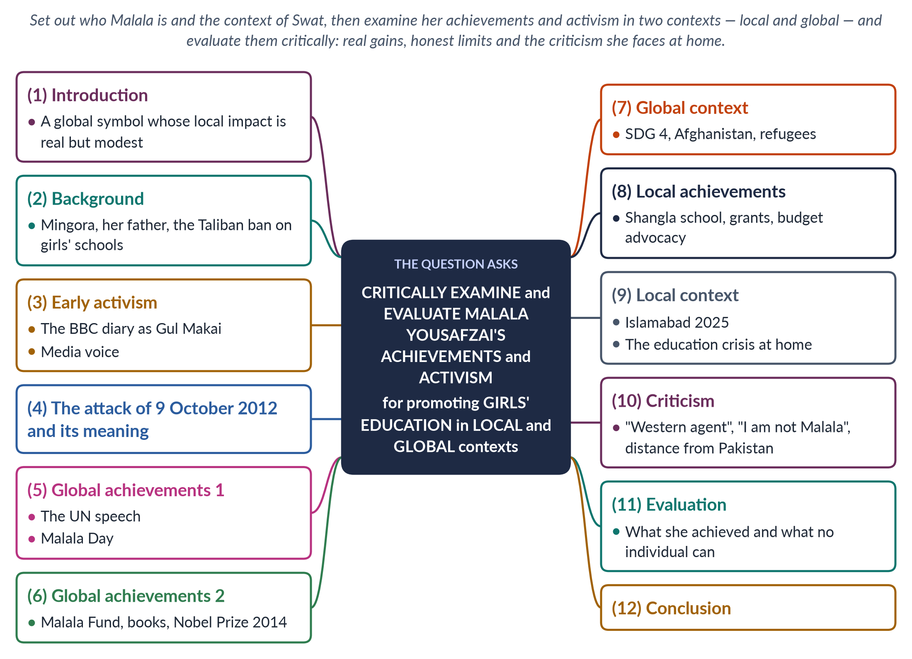
Figure 24 · The answer map: every branch is one numbered heading of the model answer below.

Decoding the question
"Critically examine and evaluate" asks you to assess achievements and limits fairly, not to write a eulogy. "Achievements and activism" covers both what she has won and what she does. "Local and global contexts" means two clear sections: her impact in Pakistan and her impact worldwide. End with a balanced judgement.

The model answer

1. Introduction

i) Who she is
Malala Yousafzai, born in Swat in 1997, survived a Taliban assassination attempt in 2012 and became the world's best-known advocate of girls' education and, in 2014, the youngest Nobel Peace Prize laureate.

ii) The argument
Malala's greatest achievement is global: she turned girls' education into a cause that world leaders could not ignore and built an organisation that funds local activists in many countries. Her local impact in Pakistan is real but modest beside the scale of the country's education crisis, and she remains a divisive figure at home. Her story shows both the power of individual courage and the limits of what any individual can do without state action.

2. Background
Malala was born on 12 July 1997 in Mingora. Her father, Ziauddin Yousafzai, a teacher and education activist who ran the Khushal Public School, encouraged her to speak out. From 2007 the Tehrik-e-Taliban Pakistan under Maulana Fazlullah took control of much of Swat, banning music and women's public life, and in December 2008 ordered all girls' schools closed; more than 100 were destroyed. A military operation in 2009 drove the Taliban out.

3. Early activism
In January 2009, aged 11, Malala began writing a diary for BBC Urdu under the pen name "Gul Makai", describing life under the Taliban and her fear of losing her education. She appeared in a New York Times documentary and spoke on Pakistani television. In 2011 she received Pakistan's first National Youth Peace Prize. Even before the attack, she had become a local voice for girls' right to learn.

4. The attack of 9 October 2012
On 9 October 2012 a Taliban gunman boarded her school bus, asked "Who is Malala?", and shot her in the head; two classmates, Shazia Ramzan and Kainat Riaz, were also wounded. She was flown to Birmingham in the United Kingdom and recovered. The attack made her a global symbol: an attempt to silence a girl for wanting to go to school instead amplified her voice worldwide.

5. Global achievements 1: the UN speech
On her 16th birthday, 12 July 2013, declared "Malala Day" by the UN, she addressed the UN Youth Assembly: "One child, one teacher, one book and one pen can change the world." The speech made girls' education a mainstream international cause and was followed by global campaigns for free, compulsory schooling.

6. Global achievements 2: the Fund, books and the Nobel Prize

i) Malala Fund
In 2013, with her father, she co-founded the Malala Fund, which invests in local "Education Champions" and advocates for policies so that girls complete 12 years of free, safe, quality education — in Pakistan, Afghanistan, Nigeria, India, Brazil, Ethiopia and among refugees in Lebanon.

ii) Books
I Am Malala (2013) became a global best-seller; We Are Displaced (2019) told the stories of refugee girls.

iii) Awards
The European Parliament's Sakharov Prize (2013) and the Nobel Peace Prize (10 December 2014), shared with Kailash Satyarthi, made her the youngest laureate at 17. She later became a UN Messenger of Peace (2017) and graduated from Oxford (2020).
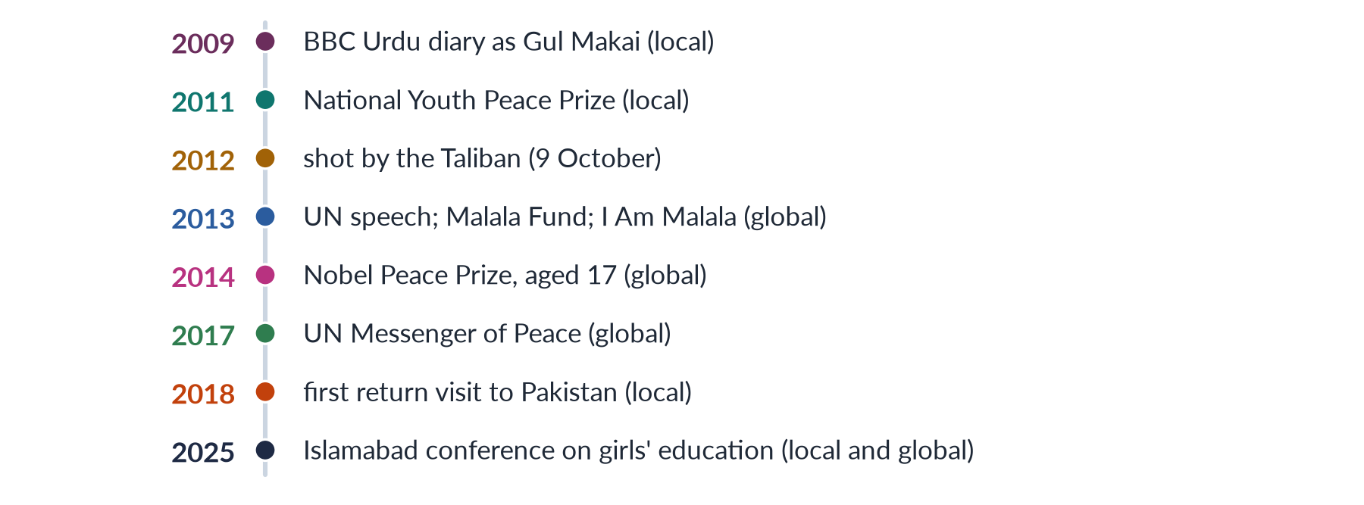
Figure 25 · Malala's activism, local and global.

7. Global context
Her activism helped keep girls' education at the centre of the Sustainable Development Goals (SDG 4, 2015). Since the Taliban's return to power in Afghanistan in 2021 and their ban on girls' secondary and higher education, she has been a leading voice calling for "gender apartheid" to be recognised as a crime in international law. She has also championed refugee girls displaced by conflict in Syria and elsewhere. Her symbolic power gives such causes a hearing in capitals and international forums.

8. Local achievements
- Shangla school: she used her Nobel prize money to support a school for girls in her ancestral district of Shangla.
- Grants: by 2025 the Malala Fund reported investing about 14.6 million dollars in Pakistan since 2013, supporting local organisations that work to get girls into secondary school, and providing emergency grants after the 2022 floods.
- Advocacy: the Fund has pressed federal and provincial governments to spend more on education and to enforce Article 25A (free and compulsory education to age 16).
- Inspiration: she has shown millions of Pakistani girls that a girl from a conservative region can become a global leader.

9. Local context
In January 2025 she returned to Islamabad to speak at the Muslim World League's conference on Girls' Education in Muslim Communities, which issued an Islamabad Declaration affirming girls' education as a religious obligation and a social necessity. Yet the local context remains grim: Pakistan has more than 25 million out-of-school children, most of them girls; female literacy is about 53%; and girls' secondary schools are scarce in rural areas. Against this scale, any single organisation's impact is necessarily limited.

10. Criticism
1. "Western agent": some Pakistanis accuse her of serving a Western agenda and shaming Pakistan abroad.
2. Conspiracy theories: some even claim the attack was staged, despite overwhelming evidence.
3. "I am not Malala": in 2014 the All Pakistan Private Schools Federation observed an "I am not Malala" day and banned her book, objecting to passages on religion.
4. Selective attention: critics ask why the world honoured her while ignoring other victims, such as civilians killed in drone strikes.
5. Distance: for security reasons she lives abroad, and some argue her influence on the ground is limited.

11. Evaluation

i) What she achieved
Global agenda-setting; an organisation investing in local activists; a moral voice on Afghanistan; and a powerful symbol that has inspired girls worldwide.

ii) Honest limits
Pakistan's education crisis is driven by low spending, insecurity, poverty, early marriage and a shortage of girls' schools — problems that require state action, not an individual's campaign. Her polarising image at home may reduce her influence with some communities.

iii) A fair judgement
Many of the criticisms reflect politics and conspiracy more than evidence; the limits reflect the scale of the problem, not a failure of her activism.

12. Conclusion
Malala Yousafzai's achievements are extraordinary: from a schoolgirl's diary in Taliban-held Swat to the Nobel Peace Prize and a global foundation, she made girls' education a cause the world could not ignore. Her global impact is profound; her local impact is genuine but modest beside Pakistan's 25 million out-of-school children. The best tribute to her activism would be for the Pakistani state to do what no individual can — build and protect schools for every girl.

Why this answer scores
- Organises achievements into local and global contexts, exactly as asked.
- Is genuinely critical: it weighs criticism and limits as well as achievements.
- Uses accurate dates and facts (1997, 2009, 2012, 2013, 2014, 2025; $14.6m; 25 million).
- A timeline figure separates local and global milestones.

Answer 12 · Short Note: The Role of Masculinity Studies in Understanding Violence against Women in Pakistan (CSS 2026)
AT A GLANCE · CSS 2026 · Q8(B) · 10 MARKS
Write short notes on: The role of masculinity studies in understanding violence against women in Pakistani society

The answer map
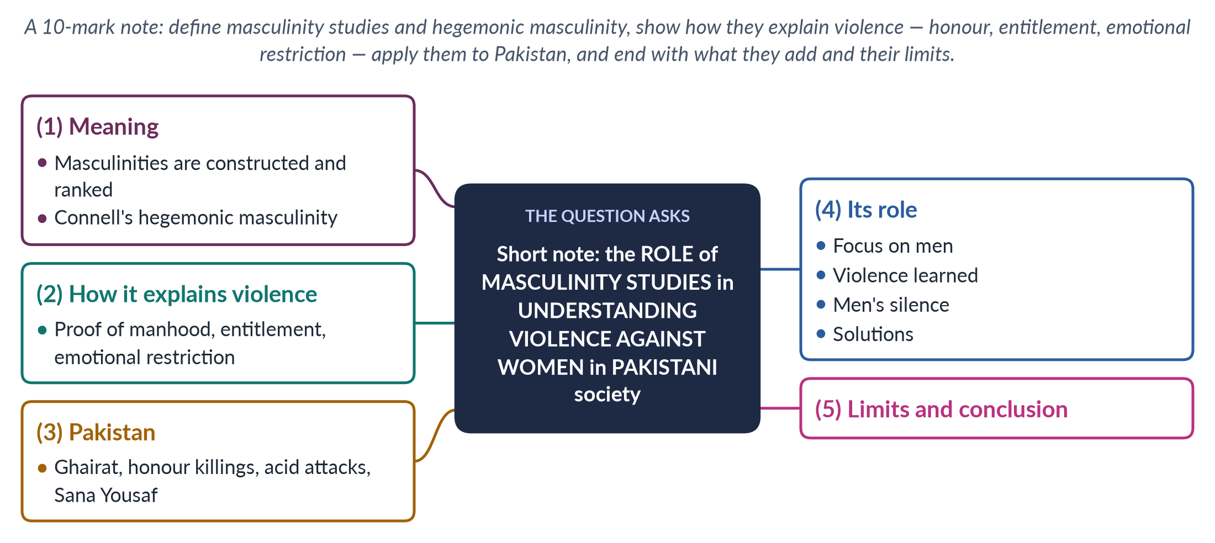
Figure 26 · The answer map for the short note: every branch is one headed point.

Decoding the question
A short note of 10 marks: about 550–650 words. Define masculinity studies and its key concepts (Connell's hegemonic masculinity), show how they explain violence against women, apply them to Pakistani society, and state what the approach adds and its limits.

The model answer

1. Meaning
Masculinity studies examines how ideas of manhood are socially constructed, how they differ across cultures, and how they shape men's behaviour. The field grew in the 1980s alongside feminism, asking not only what happens to women but what makes men act as they do. Its central insight is that there is no single, natural masculinity but several masculinities, ranked in a hierarchy. The Australian sociologist R. W. Connell (Gender and Power, 1987; Masculinities, 1995) called the dominant, culturally honoured form hegemonic masculinity — the ideal of the tough, controlling, protecting man — and argued that even men who do not match it gain a "patriarchal dividend" from women's subordination.

2. How it explains violence

i) Violence as proof of manhood
Where manhood means toughness and control, violence becomes a way to prove one is a "real man", especially when other routes to status — a good job, income — are blocked.

ii) Entitlement
Men taught that they are entitled to women's obedience treat refusal as a challenge; Michael Kimmel calls this "aggrieved entitlement".

iii) Emotional restriction
Boys are taught not to cry or show fear, so anger becomes the one permitted emotion. Michael Kaufman (1987) described a "triad of men's violence" — against women, against other men and against themselves — all rooted in this armoured masculinity.
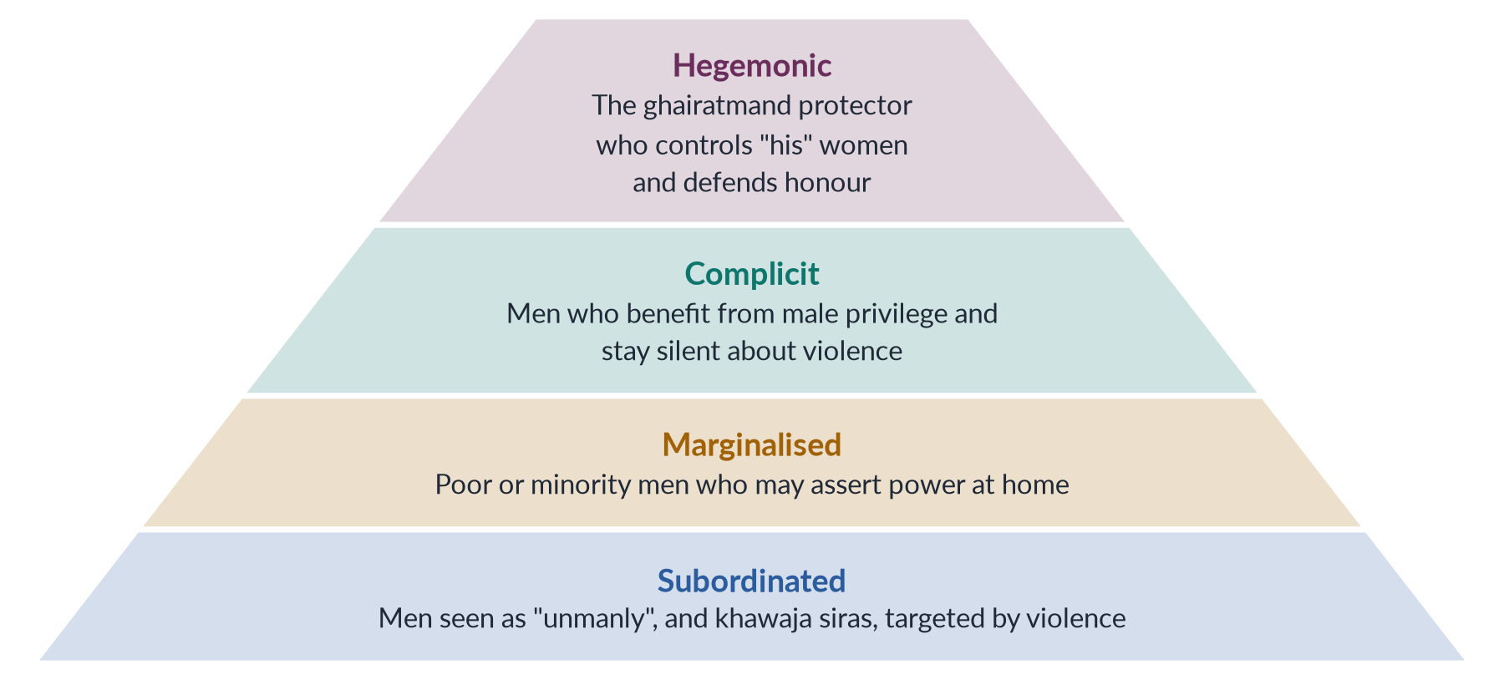
Figure 27 · Connell's hierarchy of masculinities, applied to Pakistan.

3. Applying it to Pakistan
In Pakistani society, hegemonic masculinity is bound up with ghairat and izzat — a man's honour depends on the behaviour of the women of his family. Masculinity studies shows that honour killings — at least 405 in 2024 (HRCP) — are performances of manhood before other men: a man who does not "act" fears being called be-ghairat. Acid attacks on women who refuse proposals, and the killing of the 17-year-old Sana Yousaf in Islamabad in June 2025 after she rejected a man's advances, express wounded entitlement. Sons raised with freedom and authority, and daughters with obedience, learn these roles early; dramas that romanticise jealous, possessive heroes reinforce them. Poor or unemployed men, unable to meet the provider ideal, may assert dominance at home. Jirgas and peer groups of men police these norms, approving punishments for women who "dishonour" a family.

4. Its role in understanding violence
1. It shifts the focus to men, the main perpetrators, rather than asking why women "provoke" or "stay" — a correction to victim-blaming explanations.
2. It shows that violence is learned and changeable, not natural — consistent with social learning theory.
3. It explains men's silence: complicit men benefit from the patriarchal dividend or fear being seen as weak, so few men speak out against violence by their relatives and friends.
4. It points to solutions: programmes with boys and men, such as those of the Islamabad NGO Rozan (founded 1998), the White Ribbon Campaign and UN Women's HeForShe (2014); and role models of non-violent manhood, such as Ziauddin Yousafzai, who championed his daughter Malala's education.

5. Limits and conclusion
Masculinity studies must not excuse violence as the product of "stressed" men, divert funds from women survivors, or apply Western concepts without adapting them to Pakistan's joint families and tribal structures; and "engaging men" programmes vary in effectiveness. Used carefully, however, it is essential: it explains why men commit most violence, why that violence takes honour-based forms in Pakistan, and why changing men's ideas of manhood is as important as protecting women. It complements, rather than replaces, women-centred protection and justice: women need shelters, protection orders and convictions today, while changing masculinity is the work of a generation.

Why this answer scores
- Defines the field and uses its key thinkers (Connell, Kaufman, Kimmel).
- Applies the concepts to Pakistani realities (ghairat, honour killings, acid attacks, Sana Yousaf 2025).
- States clearly what the approach adds and its limits, in a compact note.
- A pyramid figure shows Connell's hierarchy in a Pakistani setting.

